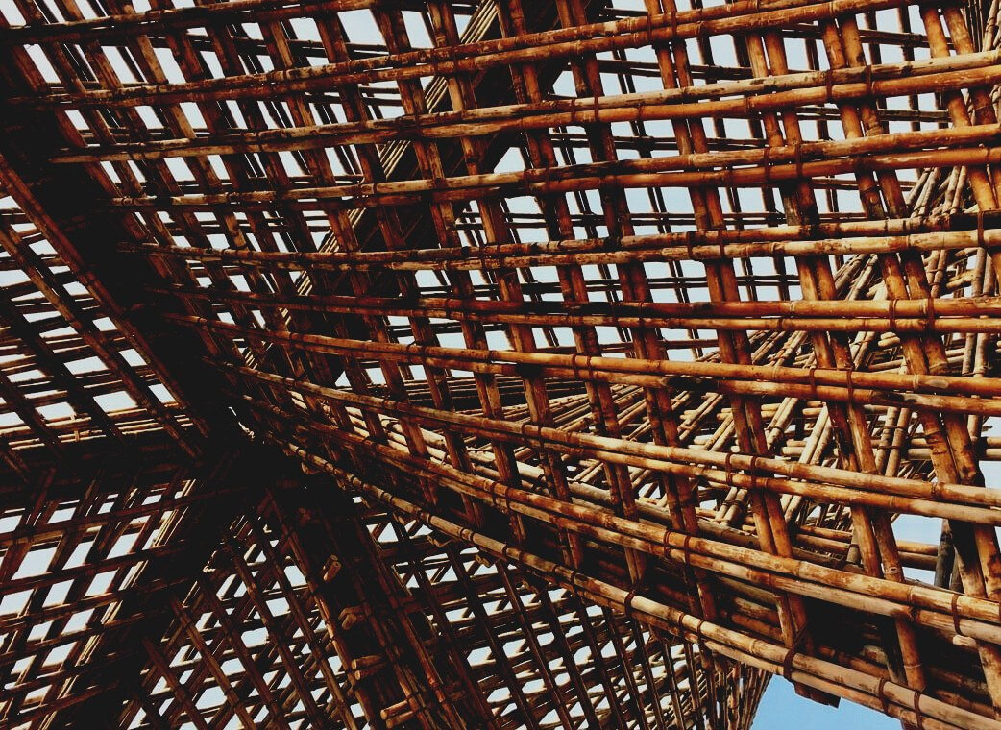

UPWOOD
Up-skilling construction workers in wood construction methods for energy-efficient buildings

UPWOOD
Up-skilling construction workers in wood construction methods for energy-efficient buildings

methods for energy-efficient buildings

UPWOOD
Up-skilling construction workers in wood construction methods for energy-efficient buildings

methods for energy-efficient buildings

UPWOOD
Up-skilling construction workers in wood construction methods for energy-efficient buildings

methods for energy-efficient buildings

UPWOOD
Up-skilling construction workers in wood construction methods for energy-efficient buildings

truction methods for energy-efficient buildings

UPWOOD
Up-skilling construction workers in wood construction methods for energy-efficient buildings

methods for energy-efficient buildings

UPWOOD
Up-skilling construction workers in wood construction methods for energy-efficient buildings

methods for energy-efficient buildings

UPWOOD
Up-skilling construction workers in wood construction methods for energy-efficient buildings

methods for energy-efficient buildings

UPWOOD
Up-skilling construction workers in wood construction methods for energy-efficient buildings

TRAINING & ASSESSMENT
MATERIAL

Learning Unit 3

TRAINING & ASSESSMENT
MATERIAL

Learning Unit 4
- Lesson 1: Energy-efficiency value of wood as a building material and wooden constructions.

TRAINING & ASSESSMENT
MATERIAL

Learning Unit 4
- Lesson 1: Energy-efficiency value of wood as a building material and wooden constructions.

TRAINING & ASSESSMENT
MATERIAL

Learning Unit 4
- Lesson 1: Energy-efficiency value of wood as a building material and wooden constructions.

TRAINING & ASSESSMENT
MATERIAL

Learning Unit 4
- Lesson 1: Energy-efficiency value of wood as a building material and wooden constructions.

TRAINING & ASSESSMENT
MATERIAL

Learning Unit 4
- Lesson 1: Energy-efficiency value of wood as a building material and wooden constructions.

TRAINING & ASSESSMENT
MATERIAL

Learning Unit 4
- Lesson 1: Energy-efficiency value of wood as a building material and wooden constructions.

TRAINING & ASSESSMENT
MATERIAL

Learning Unit 4
- Lesson 1: Energy-efficiency value of wood as a building material and wooden constructions.

1. CASE STUDIES 3
CASE STUDY 1 3
CASE STUDY 2 3
CASE STUDY 3 3
CASE STUDY 4 4
CASE STUDY 5 4
CASE STUDY 6 4
CASE STUDY 7 6
CASE STUDY 8 7
CASE STUDY 9 9
CASE STUDY 10 10
CASE STUDY 11 12
CASE STUDY 12 13
CASE STUDY 13 14
2. QUESTIONS AND ANSWERS (FAQS) 16
3. MULTIPLE CHOICE QUESTIONS 20
4. CASE STUDIES AND APPLICATION SCENARIO ANALYSIS 25

CASE STUDIES
WORK PLANNING AND TEAM MANAGEMENT

CASE STUDY 1
Tasks are jobs or activities that require time and resources. Duration of the task can be calculated using either the job availability or by workgroup’s labour requirements.
In this example lets calculate the duration of task if the number of tasks is 100 m2, job availability is 10,00 m2/shift and labor requirement is 0,70 employee hours/m2. One shift includes 7,5 hours of work.
Duration of task: (Number of tasks x labor requirement) / workgroup
(100 m2 x 0,70 employee hours/m2) / 7,5 employee hours = 9,33 (shifts)
As a result, 9,33 shifts are required to complete tasks of 100 m2.

CASE STUDY 2
Calculate the required workgroup to complete a task of 230 m2 in two-shift work for seven days. One shift includes 7,5 hours of work and labor requirement is 0,25 employee hours/m2.
Required workgroup: (Number of tasks x labor requirement) / Duration
(230 m2 x 0,25 employee hours/m2) / 14 shifts = 4,107…
As a result, at least 4 employees is required to complete the work.

ERGONOMICS AND LABOR SAFETY

CASE STUDY 3
Consider your current job or work history for a moment. What safety risks do you recognize in your work? Divide your findings in following groups:
• Risks associated with doing the job
• Risks due to working conditions
• Risks related to the work environment
• Risks arising from work planning and management

CASE STUDY 4
Have you been instructed to identify and address potential bad routines or to make observations of your work environment? What kind of observations have you made?
A good way to identify unnecessary risk-taking, address bad routines, and prevent as many accidents as possible is to ask employees at the collaborative site to make observations of their work environment that are documented on either an electronic or paper basis.

GUIDELINES FOR TRANSPORTATION AND STORING

CASE STUDY 5
List the things that needs to be considered when choosing the type of transportation. Key factors may be i.e. the value and properties of goods. What else would you apply? Justify your choices.

ARCHITECTURE DESIGN

CASE STUDY 6
Steps in the building design
The concept of Building Design refers generally to the representation of elements related to architecture and engineer.
Usually, the one the make the design is an architect in charge of representing the building trades, being able to reach the specific needs, there are five steps leading to the final design of a building.

Enumerate the different part of the design of a building explaining in what consist each one of them.
Steps of building design | What they consist of …
Schematic design | The architect speaks with the client and establish the requirements and objectives of the project. The architect starts with a series of sketches or simple renders to show the basic concepts of the design. This part includes special relations, scales, and basics shapes that the client could want. The approximate costs are presented to the client to take the opportunity on the decisions of the design and during this phase is still possible to make changes and decided shapes.
Design phase | Resume of all the data collected in the previous steps. The process analyses materials, positions of holes and general structural details.
Filling of documentation | Constructive documents can be filled. The designs now are much more detailed and are used for the construction phase and the final decisions on materials. The design is sent to contractors for price reports and to the construction department for construction licences.
Negotiation phase | Depend on the type of project. Sometimes a negotiation phase is needed to decide all the details of the construction and make agreements with all the parts involved.
Construction phase | Thanks to the building design, it is possible to achieve the complete realization of the finish proposal constructing the final building.

CASE STUDY 7
The concept of Building Design refers generally to the representation of elements related to architecture and engineer. A client entrusts a cabin in the wood. The building must be no more than 40 square meters and an open space with all the needs included in a proper home such as bedroom area, kitchen, bathroom and living space. A deck could be included, and the material used must be wood.
Then, given this information:
Solve the first and second part of a building design making sketches of the building and completing the design phase.

Examples
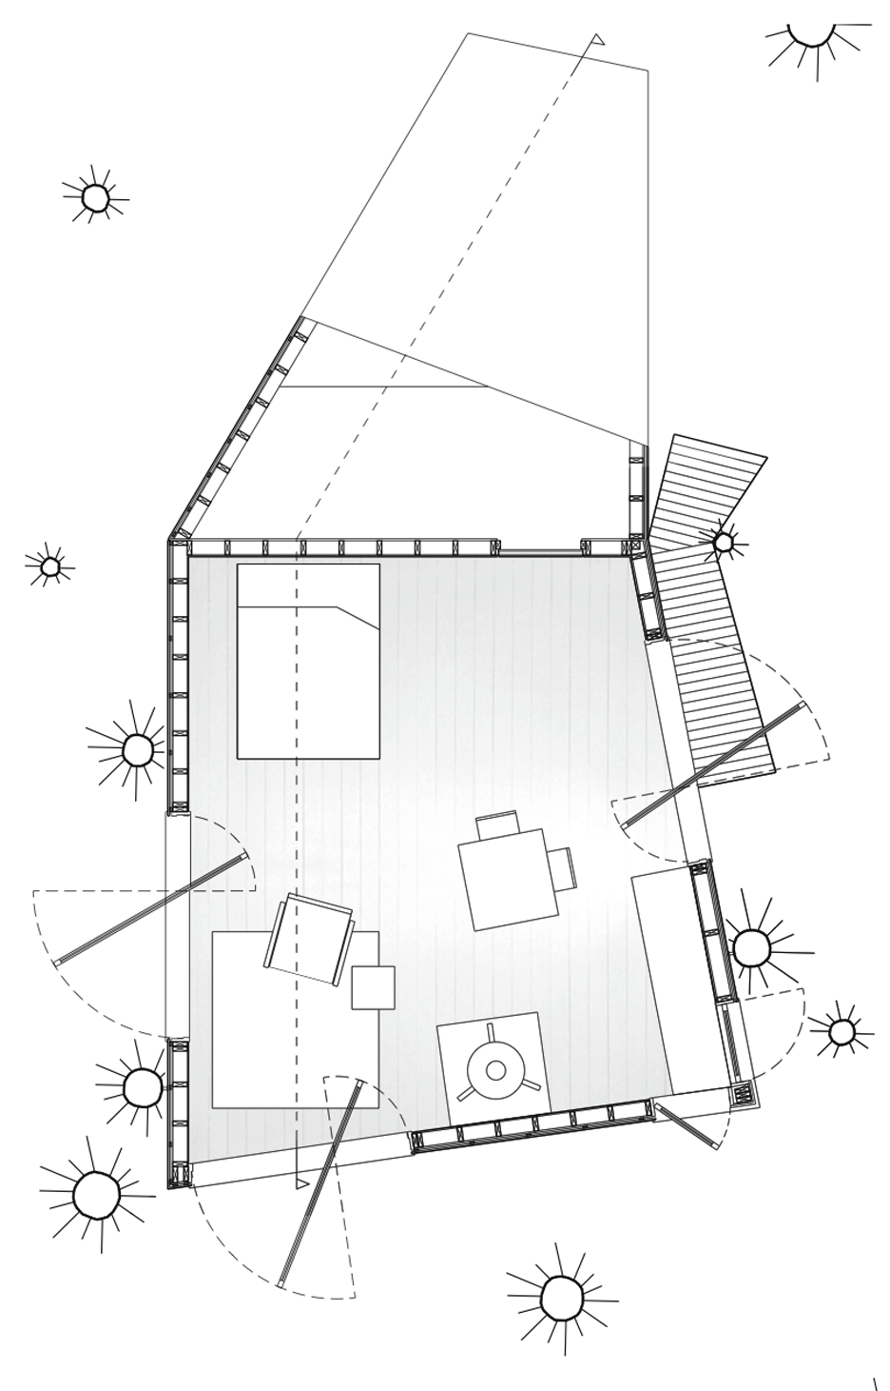
First sketches of the project-Jacobs Chang
Source: web 1

Half Tree House-Jacobs Chung Source: web 1

Bibliography
-web1:
https://www.architectmagazine.com/project-gallery/half-tree-house_o
BUILDING PHYSICS, INSTALLING OF VAPOUR BARRIER AND RISKS OF THE RESULTING CONDENSATION

CASE STUDY 8
It is so obvious the necessity of the installation of a vapour barrier element in every outer wall of the building. It provides great conditions for the interior spaces and preserves the durability of every constructive element.
Once it is well acknowledged the relevance of this sort of constructive elements, it is also important to have in mind:
What could be the consequences of not installing the vapour barrier in the wall of a building?
Waste of insulation materials | Without the adequate short vapour barrier, the air condensates in the interior of the wall, which means that insulation elements might be in contact with water. Depending on the material used for the insulation, this can seriously damage and decrease the insulation properties.
Troubles with ambient conditioning | If the insulation material is vulnerable to the contact with water, that means that the insulation would stop working adequately. For that reason, the lack of vapour barrier would conclude on some conditioning issues, due to the missing insulating properties.
Wetting of enclosure elements | Of course, if there is some water in the section of the wall, and there is no element to prevent it to damage other elements, the water will cause different damages to every vulnerable layer of the wall. In case of wood elements, the water could cause some troubles with mold, due to the different water vulnerabilities of the wood.
Interior humidity levels | In case this elements start to show some humidity issues the wood would lose its hygrothermal properties temporarily, and relative humidity levels in the interior spaces would present some problems.

CASE STUDY 9
List some of the most useful materials and systems to provide an adequate vapour barrier to the building enclosures, and name some of their properties:
Material | Properties
Polyethylene film | The good properties of this material are its cheapness and the ease of its installation. Nevertheless, one of the most important properties is its  Complete seal to water and air. This is a very negative feature, since it blocks the blow of air through the walls, delaying the hygrothermal properties of wood
Film membrane | This material offers good behaviour towards condensation and protects against water penetration, can resist huge change temperatures, gives a proper interchange of gases between interior and exterior
Clay plaster | Clay plaster has really good properties as a vapor barrier, since it behaves adequately against air condensations. It is also a very breathable material, which combined with wood constructed buildings, would provide the wall with really great hygroscopic qualities.
Lime plaster | This material is permeable and allows the flow of vapours and air through the material. It has fungicide properties, which means that it avoids the growth of any sort of mold. In addition, it presents good behaviour against water.

FIRE SAFETY AND PROTECTION SOLUTIONS

CASE STUDY 10
Assessment of fire load density according EC 1 part 2 Annex E
Task
What is expected design fire load density in the dwelling about which is known:
- Area 35 m²
- Inside the room are 300 kg of wooden furniture, 10 kg of PVC materials, 100 kg textiles and 3 kg of paper
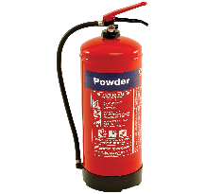
- The room is equipped with smoke detector and alarm system. There is fire extinguisher and the main exit rout is through the protected staircase.
Wooden furniture 300 kg
PVC materials 10 kg
Textiles 100 kg
Paper 3 kg
Fire alarm
Smoke detector
Fire extinguisher
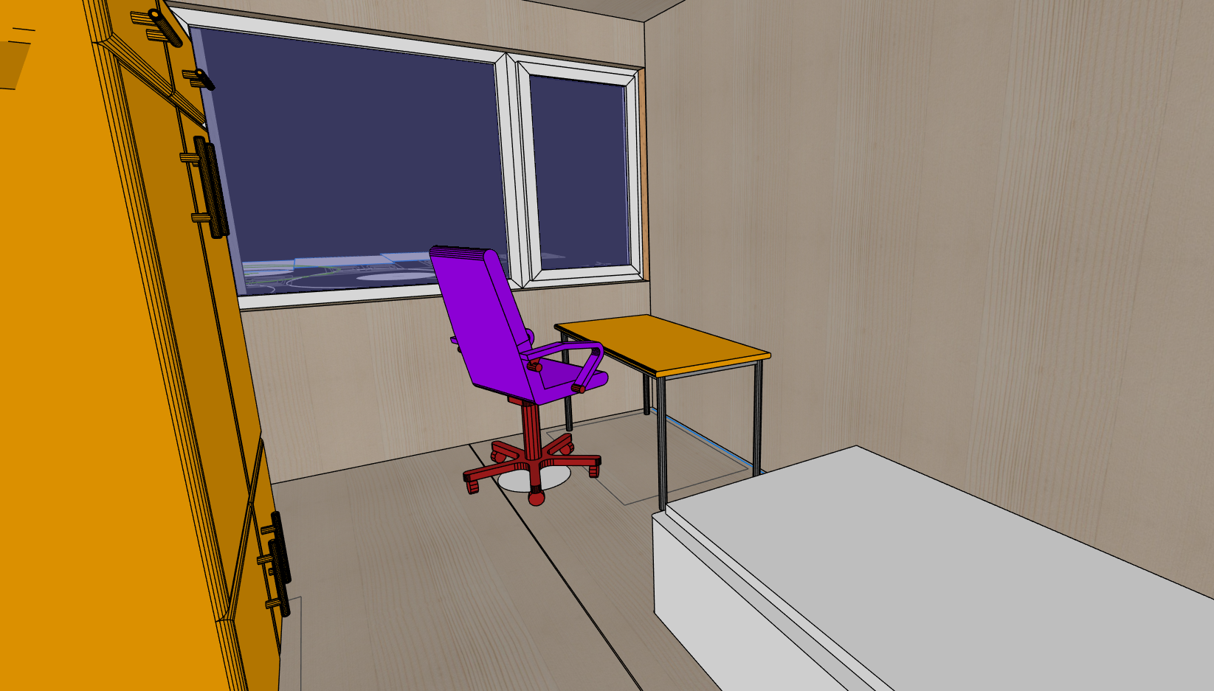
Solution
- Step 1 - combustion heat using EN 1991-1-2 equation E.2 for each of described materials in the room.
- Step 2 - characteristic fire load using EN 1991-1-2 equation E.3 using obtained data from step one and information about room area.
- Step 3 – Compartment size fire activation factor – EN 1991-1-2 Table E.1.
- Step 4 – Occupancy related fire activation factor – EN 1991-1-2 Table E.1.
- Step 5 – Factor of active firefighting measures – EN 1991-1-2 Table E.2 and equation form notes under equation E.1.
- Step 6 – Design fire load – EN 1991-1-2 equation E.1. Combustion factor m=0,8.

CASE STUDY 11
Assessment of fire separating function of simple CLT fire wall
Task
What is expected resistance to fire class for separating function parameters (EI) of massive timber wall with two layers of F type gypsum plaster from both sides and additional insulation layer from exposed side of the wall?
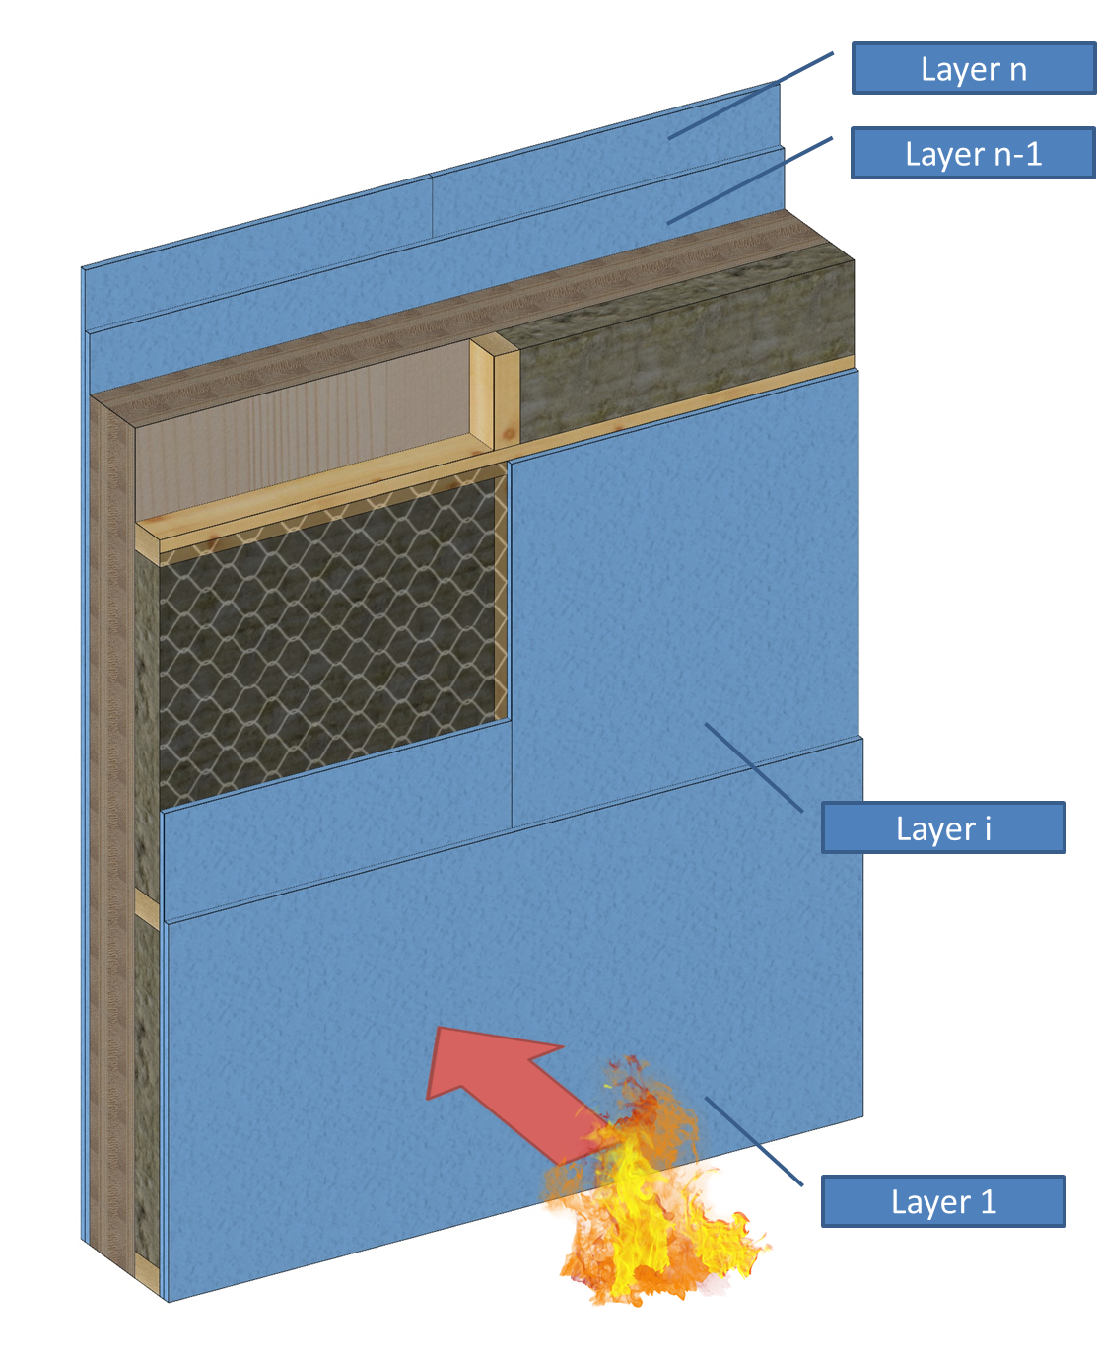
Solution
Step 1 – Definition of materials
Step 2 – Calculation of fire protection time for each layer using Technical guideline for Europe SP Report 2010:19
Step 3 – Calculation of insulation time of wall structure
Step 4 – Calculation of fire resistance time for Integrity and Insulation parameters according SP Report 2010:19 method
Step 5 – Classification of the wall structure
THERMAL INSULATION MATERIALS

CASE STUDY 12
Task: Please calculate coefficient of heat transmission (U-value) to the brick wall (U_{tot}) with parameters below:
Material | Clay bricks | Glasswool | Concrete blocks | Plaster
Thickness, m (B) | 0.100 | 0.100 | 0.100 | 0.013
Conductivity  (k-value), W/m⋅K (K) | 0.77 | 0.04 | 1.13 | 0.50
Outside surface R-value 0.040 Km²/W and Inside surface R-value: 0.130 Km²/W
Solution:
U-value calculations can be made in the following way, by considering the building element’s construction layer-by-layer. Note, however, that this does not account for cold bridging (by wall ties for example), air gaps around insulation, or the different thermal properties of e.g., mortar joints.

Step 1. Calculate resistance value (R-value) to each material (R_{i}):
Material | Thickness | Conductivity  (k-value) | Resistance  (R-value)
Equation | B_{i} | K_{i} | R_{i}=B_{i}/K_{i}
Outside surface | – | – | 0.040 K m²/W
Clay bricks | 0.100 m | 0.77 W/m⋅K | 0.130 K m²/W
Glasswool | 0.100 m | 0.04 W/m⋅K | 2.500 K m²/W
Concrete blocks | 0.100 m | 1.13 W/m⋅K | 0.090 K m²/W
Plaster | 0.013 m | 0.50 W/m⋅K | 0.026 K m²/W
Inside surface | – | – | 0.130 K m²/W

Step 2. Calculate resistance value (R-value) to the wall (R_{tot}):
R_{tot}=R_{Out}+R_{Bricks}+R_{Wool}+R_{Blocks}+R_{plaster}+R_{ins}=0.040+0.130+2.500+0.090+
+0.026+0.130=2.916 K m²/W

Step 3. Calculate coefficient of heat transmission (U-value) to the wall (U_{tot}):
U_{tot}=1/R_{tot}=1/2.916=0.343 W/m²K

Note that in the above example, the conductivities (k-values) of building materials are freely available online; in particular from manufacturers of materials. In fact, using manufacturer data will improve accuracy, where specific products being specified are known at the time of calculation.

CASE STUDY 13
Task: Please calculate Conductive Heat Transfer (Q_{tot}) through a flat wall (from Case study 1), with building wall size (H)3m x (L)15m and temperature outside (-15C) and inside (+22C).
Solution:
Step 1. Calculate building wall area A.
A = HxL = 3x15=45m²

Step 2. Calculate temperature difference (ΔT)
ΔT = T₁ – T₂=-15 – 22 = -37C

Step 3. Calculate thermal conductivity from Case study 1.
K_{tot}=K_{Bricks}+K_{Wool}+K_{Blocks}+K_{plaster} = 0.77+0.04+1.13+0.50=2.44 W/m⋅K

Step 4. Calculate thickness of wall
B=Sum (B_{i}) = 0.100+0.100+0.100+0.013=0.313 m
Step 5. Calculate for conductive heat loss or gain through a flat wall (Q)
Q = k x A x ΔT / X = 2.44x45x(-37)/0.313 = ̴-12980W = ̴-13 KW
where Q is the heat loss or gain (W or Btu/h);
k is the thermal conductivity (W/mK or Btu/(hr ft °F));
A is the area of heat flow (m² or ft²);
ΔT is the temperature difference (C or F);
X is the thickness of material (m or in.).

QUESTIONS AND ANSWERS (FAQS)
WORK PLANNING AND TEAM MANAGEMENT
What is leadership?
Management includes all the guiding or evaluative activities that are performed in the organization to specify goals and guide activities according to the set goals.
Why is work planning so important?
The person undertaking the construction project must lead and direct the project as a whole, which considers both the project planning, procurement, and the time that needs to be required for the construction phases.

ERGONOMICS AND LABOR SAFETY
Who is responsible for site safety?
The main contractor must ensure, through familiarization and guidance, that all employees on the joint construction site have adequate knowledge of safe working.
What does orientation mean?
Orientation is a measure required by the Occupational Safety Act, documented with a signature when an employee arrives at a new job site.
What are the issues related to device safety?
CE marking, reading the manufacturer's operating instructions, using protective equipment, checking the condition of the device before use, and using the device following the instructions.

TRANSPORTATION AND STORING
Why should a plastic cover be removed from the wood material, especially if the storage time is long?
When protecting materials and structures, it is considered that the water absorbed into them can escape freely from them.
Why should interim storage be on a flat surface and off the ground?
The protection of wood material during storage, transport, and interim storage are important because the wood material tends to equilibrate with the surrounding conditions.

ARCHITECTURE DESIGN
What the concept of building design refers to?
The concept of Building Design refers generally to the representation of elements related to architecture and engineer.
Which are the five steps leading to the final design of a building?
The steps are: 1. Schematic design; 2. proper design phase; 3. constructive documents; 4. negotiation phase; 5. construction.
Is the architecture design an objective or subjective task?
It is both, since the design of architectural spaces carries both the need of providing the best living and activity quality and the development of an interesting and beautiful piece of art.

BUILDING PHYSICS, INSTALLING OF VAPOUR BARRIER AND RISKS OF THE RESULTING CONDENSATION
Why are is it so important to install the vapour barrier?
Due to the heat difference between the inner surface and the outer surface of the wall section there is a point where the strong difference of temperatures makes the air condensate, dropping particles of water which can seriously damage the inner layers of the wall.
Which are the consequences of not considering the behaviour of wood against vapour condensations?
The consequences of not considering the behaviour of wood can cause:
- swelling of walls,
-collapse of the building due to the increase of density of the wood,
- problems with the finishing coat and cladding of the walls,
- mold at the corner of the building,
- deformation of the walls due to cracking and freezing water,
- absorption of humidity by the isolation material and consequent destruction of it.
Which are the construction materials available for short vapor barrier?
The construction materials available for short vapor barrier are plastics such as polyethylene film, fillers and film membrane, and also other materials which work with wet technologies such as Clay plaster or Lime plaster.

FIRE SAFETY AND PROTECTION SOLUTIONS
What are basic components necessary to fire occur?
Fuel, oxygen and heat source
What can be told about construction product when reaction to fire class B-s1, d0 is affixed to it?
Construction product can withstand prolonged fire exposure, more than 20 min. without significant contribution to fire. During this time, it emits small amount of smoke and does not spread flaming droplets.
What calculation approaches are available to assess resistance to fire performance of simple timber frame wall?
There are three methods: Prescriptive fire model, parametric fire model and Advanced fire model. In particular case, if no other information is available about building, the resistance to fire performance can be assessed using prescriptive fire model.

THERMAL INSULATION MATERIALS
Why are heat insulation materials is needed for buildings?
Heat insulation materials is used for buildings to:
- Reduce the amount of energy used for warming or cooling building.
- Insulation of building has the greatest potential for reducing CO² emissions in heat / cooling devices in building.
- To reduce sound from outside to inside and opposite.
- To improve fire safety of building.
What can be understood with term “thermal bridge”?
A thermal bridge occurs when there is a gap between materials and structural surfaces. The main thermal bridges in a building are found at the junctions of facings and floors, facings and cross walls; facings and roofs, facings and low floors.
How to choose the best insulation material from many types of insulation?
To choose the best type of insulation, you should first determine the following:
- Where you want or need to install/add insulation
- The recommended R-values for areas you want to insulate

MULTIPLE CHOICE QUESTIONS
WORK PLANNING AND TEAM MANAGEMENT

Informing about construction site primarily serves
a) people to avoid unnecessary movement in the area.
b) home buyers and investors interested in construction site to get in touch with the builder.
c) only the authorities.
The basic task of management is to
a) provide a place-time diagram to divide the site into blocks and sub-sites.
b) support activities of the organization and create best possible conditions for high-quality and productive work.
c) lead people with interactive and influencing behavior.

ERGONOMICS AND LABOR SAFETY

Investments in occupational safety are
a) made through communication, occupational safety competitions, and general priorization of occupational safety.
b) made by acquiring new protective equipment for all employees once a year.
c) made by training personnel through occupational safety lectures, practical exercises and first aid training.
Personal protective equipment
a) are usually used only as an identifier for working on a construciton site.
b) prevents injuries and exposures in work.

Who is responsible for using protective equipment provided by employer?
a) Employer.
b) Employee.

GUIDELINES FOR TRANSPORTATION AND STORING

The aim is that the storage conditions are as close as possible
a) to conditions during use.
b) to the conditions during manufacturing i.e. planing process.
The materials are protected from moisture
a) by keeping them off the ground with sufficiently high washers and that the material is ventilated accordingly.
b) by keeping them off the high enough that any water droplets cannot splash on the material in case of rain.
c) by ventilating the surface with an air cap between the material and waterproof protective cover.

ARCHITECTURE DESIGN

Which is the main task of an architect in the development of an Architecture Project?
a) Draw only the first sketches of the shape of the building.
b) To design the building, regarding all special needs required for the proper conditions for the building, and taking responsibility of every development in the project construction.
c) Only filling the required documents with its name and responsibility.

Is the design of a building a simple and objective task?
a) No, the process of designing a building is a very tedious task, which require a lot of development, and several corrections during the process.
b) Yes, designing a building is a step-by-step task.
c) The adequate design of a building is not important.
Who is involved in the process of designing a building?
a) Only the architect.
b) Only the client. The architect only designs what the client asks to.
c) Every agent involved in the development of the project, from the architect and the client, to every specific professional that carries any technical role in the project

BUILDING PHYSICS, INSTALLING OF VAPOUR BARRIER AND RISKS OF THE RESULTING CONDENSATION

What are the consequences of not considering the vapour barrier in timber construction buildings?
a) There are no consequences, sealing the surface of the sheathing is enough to provide tightness to the building and protecting the enclosure elements.
b) There are several negative consequences from deteriorating the enclosure look, to serious damages that may lead to the collapse of the building.
c) The consequences only affect to the appearance of the building. The damages cannot interfere in the building stability.

Polyethylene film has a great behaviour against vapour condensations.
a) False. Polyethylene film works only as an insulation material.
b) True. Polyethylene is a great material as vapour barrier, with no downsides.
c) True, but it has the downside of completely blocking the air circulation, and impeding the air flow through the wall.
The main technology/technologies that works for the short of vapour barrier is/are:
a) Both Dry technology and Wet technology. Each of them works different, but both are useful for the short of vapour barrier.
b) Only Dry technology systems, such as films and membranes.
c) Only Wet technology systems, such as clay plaster or Lime plaster.

FIRE SAFETY AND PROTECTION SOLUTIONS
Which of standard fire curves should be used to predict temperature rise in the compartment where are stored bundles filled with diesel?
- Standard fire curve
- Hydrocarbon fire curve
- External fire curve
Which of fire resistance classification symbols represent structural stability of structure during the fire?
- “E”
- “W”
- “R”
- “S_{a}”

In what conditions Smouldering fires can occur?
- Combustible materials are set on fire in the compartment with unlimited supply of air.
- Combustible materials are set on fire in the compartment with controlled supply of air.
- Combustible materials are set on fire in the compartment with small amount of air supply.

THERMAL INSULATION MATERIALS

In which building stage is easiest to determinate and predict thermal bridges in building?
- When building is finished, by thermal camera.
- When building is populated. Usual in winter time.
- In design stage.

Which of symbols represents thermal resistance?
- “λ”
- “R-value”
- “U-value”
- “K-value”

Is it economic to build house with unlimited heat insulation thickness?
- Yes, more heat insulation material means warmer building in Winter time.
- No. Heat insulation material should be close to Economic Thickness.
- Economic parameters and heat insulation material thickness aren’t connected.

CASE STUDIES AND APPLICATION SCENARIO ANALYSIS
FIRE SAFETY AND PROTECTION SOLUTIONS
1. What could be expected temperature inside the ordinary dwelling 22,5 minutes after fire breakout?
Solution
Student has to choose appropriate standard fire scenario and read the data from graph or do calculation according EN 1991-1-2 using appropriate equation (3.4), (3.5) or (3.6).

THERMAL INSULATION MATERIALS
2. Task: The buyer cannot decide which house to build: wood or brick house. But it wants to have building with the same thickness (0.35m), and with less conductive heat loss. Please help him (calculate only walls, without windows and doors).
House wall consist of
Wood house |  |  | Brick house
Material | Thickness, mm | Material |  | Thickness, mm
Plaster | 25 | Plaster |  | 25
Wood fibreboard | 50 | Brick, insulating |  | 300
Wood pulp | 210 | Rockwool |  | 50
Wood fibreboard | 50 | Gypsy board |  | 24
Clay, dry | 15 | Plaster |  | 15

R value for: outside surface - 0.040 K m²/W and inside surface - 0.130 Km²/W,
House wall size: 3m (H) x 40m (L)
Temperature difference is 41⁰C.
Materials thermal conductivity please find in Engineering tool box.

Solution
Student has to calculate heat losses in both buildings and compare it.

For example: Engineering tool box. Thermal Conductivity of some selected Materials and Gases. Accs. https://www.engineeringtoolbox.com/thermal-conductivity-d_429.html
Engineering tool box. Thermal Conductivity of some selected Materials and Gases. Accs. https://www.engineeringtoolbox.com/thermal-conductivity-d_429.html

