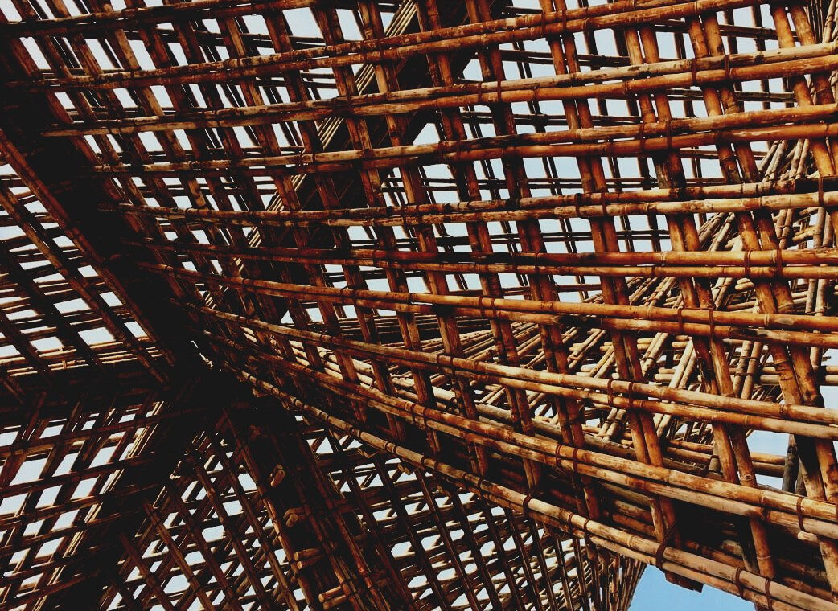

ASSESSMENT MATERIAL

Learning Unit 2
THE USE OF CONSTRUCTION PRODUCTS
UPWOOD
Up-skilling construction workers in wood construction methods for energy-efficient buildings

UPWOOD-PUU
Rakennustyöläisten ammattitaito energiatehokkaiden rakennusten puurakentamisenmenetelmissä

UPWOOD
Rakennustyöläisten ammattitaito energiatehokkaiden rakennusten puurakentamisenmenetelmissä

UPWOOD-PUU
Rakennustyöläisten ammattitaito energiatehokkaiden rakennusten puurakentamisenmenetelmissä

Table of contents
1. Frequently asked questions 2
2. Multiple choice questions 3
3. Case studies 3
3.1 Case study 1 3
3.2 Case study 2 3

Frequently asked questions
Question: What is a module element?
Answer: The module element is a torsionally rigid and transport-resistant, finished housing block, so the construction time is significantly shortened, and the quality of construction is improved.
Question: What is the CE mark?
Answer: The CE marking facilitates the sale of products from one country to another and indicates the suitability of construction products if the product is covered by the hEN or the EEA. The CE marking ensures that the characteristics of products are always indicated in the declaration of performance in such a way that both designers and consumers can easily compare construction products.

Multiple choice questions
- Eco-labels are used to
  - indicate that the product can be freely disposed of as mixed waste at the end of the product’s life cycle.
  - indicate that the manufactured product complies with the requirements defined for the manufacturing process, such as product life cycle, energy consumption and responsibility.
  - indicate that the product is made only from renewable or recycled materials.
- In general, external doors must meet various requirements, i.e. thermal insulation and sound insulation. How do you read thermal insulation’s U-value?
  - The lower the U-value, the better is its thermal insulation. A door consisting a low U-value reduces waste heat and energy.
  - The higher the U-value, the better is its thermal insulation. A door consisting a high U-value reduces waste heat and energy.
- MSE standardized window type means:
  - 2 frame and 3 glass window, opening inwards
  - 2 glass window, opening both in- and outwards
  - Single frame glazed with 2 or 3 glass elements, opening inwards

Case studies

Case study 1
The window square usually transfers heat almost six times more than the outer wall square. Referring to the learning material, describe the points to consider when installing a window. What things should be considered during installation and finishing?

Case study 2
What things you should consider when installing the exterior door? If necessary, see more in the learning material.

