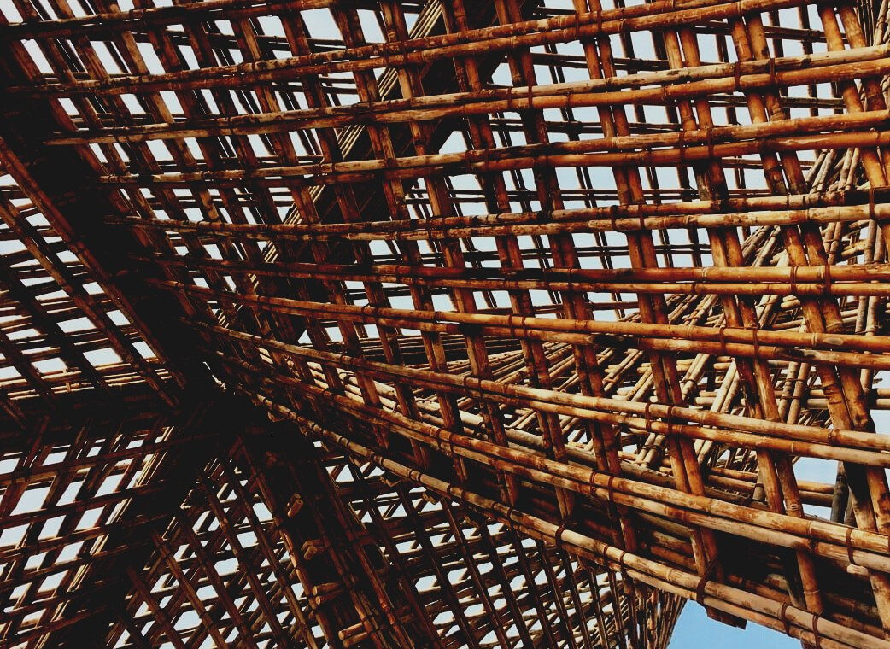

**TRAINING & ASSESSMENT**

**MATERIAL**

Learning Unit 1

Lesson 2: Possibilities of improving the properties of the wood and wood protection, durability.

UPWOOD

*Up-skilling construction workers in wood construction methods for energy-efficient buildings*

UPWOOD

*Up-skilling construction workers in wood construction methods for energy-efficient buildings*

*construction workers in wood construction methods for energy-efficient buildings*

*methods for energy-efficient buildings*

UPWOOD

*Up-skilling construction workers in wood construction methods for energy-efficient buildings*

*methods for energy-efficient buildings*

UPWOOD

*Up-skilling construction workers in wood construction methods for energy-efficient buildings*

*truction methods for energy-efficient buildings*

UPWOOD

*Up-skilling construction workers in wood construction methods for energy-efficient buildings*

*methods for energy-efficient buildings*

UPWOOD

*Up-skilling construction workers in wood construction methods for energy-efficient buildings*

*methods for energy-efficient buildings*

UPWOOD

*Up-skilling construction workers in wood construction methods for energy-efficient buildings*

*methods for energy-efficient buildings*

UPWOOD

*Up-skilling construction workers in wood construction methods for energy-efficient buildings*

**CONTENT**

1. INTRODUCTORY PARAGRAPH 2

2. LECTURE NOTES 3

2.1. Improvement of properties by appearance 3

2.1.1. Appearance grades – Quality classes 4

2.1.2. Stress grading 5

2.2. Technological improvement of wood properties 8

2.2.1. Improving properties by sawing and planning 8

2.2.2. Improving properties by production of wooden products 10

2.3. Chemical improvement of wood properties 10

2.3.1. Industrial wood preservatives 13

2.3.1. Wood preservatives treatment process 14

2.3.2. Non-pressure methods 14

2.4. Thermal protection of wood 15

2.5. Operational improvement of wood properties 17

2.5.1. Protection by surface covering 17

2.5.2. Protection by structure covering 18

2.6. Wood degrading microorganisms 18

2.6.1. Wood fungi 18

2.6.2. Wood colouring fungi 19

2.6.3. Mold 20

3. LIST OF REFERENCES 21

# INTRODUCTORY PARAGRAPH

As is true for all building materials – steel, or reinforced concrete and especially wood, to ensure successful performance and long life of the structure requires that the designer understands the behaviour of each material and plans accordingly so as to avoid problems that may arise due to its properties. The builders have an important role in that success and as well are the final users or the main owners of the building for long life.

In highly hazardous applications, the natural durability of wood can be insufficient, and wooden elements need to be protected by design.

From the point of view of the use of wood for construction, wood has a number of “undesirable” properties: it burns; is attacked by fungi, as well as by insects; decomposes with acids and bases; swells and shrinks. Last already mentioned in lesson 1 of LU1. In this lesson 2the possibilities to improve watering properties and fight against microorganisms are presented.

Alternatively, wood durability can be enhanced through wood preservatives or modification systems. In order to reduce undesirable properties, the chemical composition of wood and the surface or structure must be changed or modified. The word modification originates from the Latin word *Modificatio*, which indicates the determination of the correct measure (transformation of things, phenomena and processes). Wood modification (Fig.1.28.) improves the stability of the wood dimensions, reduces moisture uptake or renders it unusable for bio-degraders.

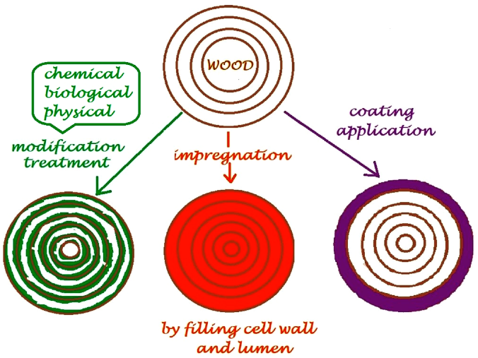

**Fig. 1.28. Schematic representation of the methods used for wood modification[1]**

New kinds of products – smart products, are created when wood is combined with other materials. These include composites made of wood and plastic or structures that react to stress. New types of special solutions can be made by de-fibering or pulping wood. By modifying wood, it is possible to improve its properties, an example of this being thermal wood, *Accoya*® etc.

# LECTURE NOTES

Wood and wood based-materials are biodegradable and require protection and sometimes improvement of properties when used in highly hazardous applications. Types of wood properties improvement:

* by appearance (sorting and grading);
* technological (use of naturally hardy tree species or gluing etc.);
* chemical (applying chemicals on surface or make treatment);
* thermal (stabilizing wood shrinking/swelling properties);
* operational (structural protection of wood, e.g. high humidity).

The purpose of wood protection is to ensure its long service (operational) life. It includes all measures which prevent premature, irreversible damage to wood caused by microorganisms and insects. The type of treatment, and how it is applied, will depend on several factors including:

* the natural durability of the species of timber;
* its resistance to penetration by preservatives (permeability);
* the end use of the timber;
* the service life required;
* the ease of any future maintenance – surface finishes and coatings.

In practice, the most widely used is structural and chemical protection, as well as wood surface treatment with coatings to reduce its wettability. Prior to installation in the building, the wood materials must be protected from moisture during transportation, storage and also during installation and assembling process wood construction elements need to be covered as fast as possible to minimize influence of environmental conditions.

## Improvement of properties by appearance

This lesson 2 starts with characterization of sawn timber materials:

* beams are sawn (half squared, square-sawn) material with a thickness and width of more than 100 mm;
* scantlings are a square-sawn material with a thickness of less than 100 mm and a width of less than twice the thickness;
* boards are sawn material with a thickness of 50 and less mm and a width of more than twice the thickness;
* battens are sawn materials with a thickness of 30 to 90 mm and a width of less than 100 mm;
* edgings are sawn material with small cross-section thickness not exceeding 25 mm and width not exceeding 80 mm.

The grade of wood can be specified using a number of parameters, including:

* cross grain, compression wood, tension wood (LU1 Lesson 1);
* knots, checks, splits, wane (in a time of timber growing of sawing)
* dimension deviations (in a time of sawing further preparation);
* fungal attack and insect damage (in a time of timber growing of exploitation)
* discolouration (in a time of timber growing of exploitation)

The parameters are assessed in visual sorting (for softwoods EN 1611-1), known as visual grading. This is usually done at sawmills. Timber materials by appearance generally are divided into groups. Different countries usually use different names for these groups. It is common for each piece of wood to be stamped on the flat-wise (flat surface) all grading information and also on the end of each board just strength class. After processing, e.g. planning or splitting, these marks may be cut away or hard to identify.

### Appearance grades – Quality classes

The timber can be sorted visually. In figure 1.29. are shown planned boards in the dimensions: 25×100, 50×150 and 75×200 mm.

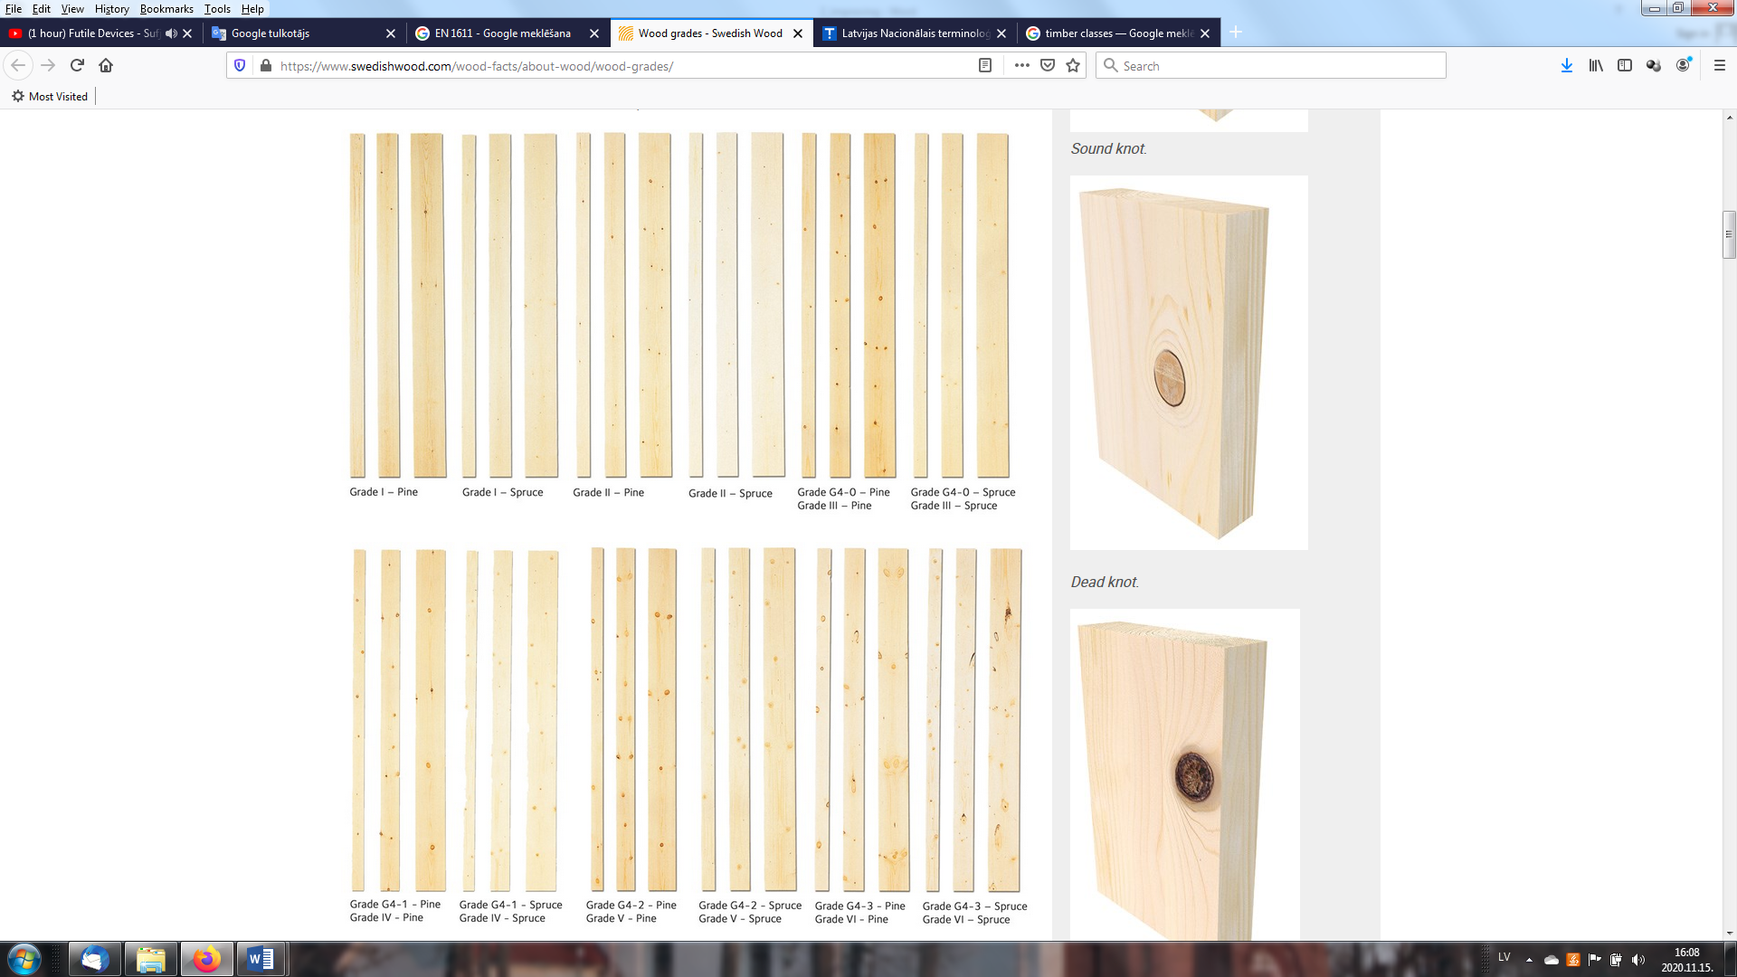

**Fig. 1.29. Appearance grades – Quality classes[2]**

Boards can be sorted based on the flat-wise and the edge-wise (G4), or only on the flat-wise (G2). The grading designations are followed by a number from 0–4 stating the quality of the wood (0 the highest). A grade can thus have the designation G4-2 (4-sided and 2 quality class). A rough comparison with the sorting rules is given in table 1.5. Under the *Nordic Timber Grading Rules*, wood is sorted into four grades: A, B, C and D (A is the highest quality). Grade A is used for exposed cladding. Grade B is the most common grade in construction, while grade C and D are used as packaging materials. *Guiding principles for grading of Swedish sawn timber* - the wood is sorted into six grades, with grade I as the highest quality, and US - unsorted.

Table 1.5.

**Timber grade classes[3]**

|  |  |  |  |  |  |  |  |
| --- | --- | --- | --- | --- | --- | --- | --- |
| **Grading rules** | **Grades – quality classes** | | | | | | |
| **EN 1611 – 1** | | | | | | | |
| 4-sided grading | - | - | G4-0 | G4-1 | G4-2** | G4-3 | G4-4 |
| 2-sided grading* | - | - | G2-0 | G2-1 | G2-2 | G2-3 | G2-4 |
| **Old grading rules** | **Grades – quality classes** | | | | | | |
| *Nordiskt trä - Nordic Timber Grading Rules* (The Blue Book) 1994 | A | | | | B | C | D |
| A1 | A2 | A3 | A4 |  |  |  |
| *Guiding principles for grading of Swedish sawn timber*  (The Green Book) 1960 | US | | | | 5th | 6th | 7th |
| I | II | III | IV | V | VI | VII |

* 2-sided grading G2, seldom used in Sweden. ** Most common for construction timber.

For oak grading by appearance standard EN 975-1: Sawn timber - Appearance grading of hardwoods - Part 1: Oak and beech, is used.

All above mentioned properties can be done by visual grading in-person or using special equipment, for example:

* [*System TM and Microtec*](https://www.youtube.com/watch?v=NoFex15PE1Y)*[4]*
* [*FinScan*](https://www.youtube.com/watch?v=iPoaGcyQ3us&feature=emb_logo)*[5]*
* [*Microtec Goldeneye 700*](https://www.youtube.com/watch?v=qFwOcHbJats)*[6]*

In general, a supplementary visual grading is also required for parameters that machines are unable to assess, such as wood defects, technological faults etc. To judge the impact of the knots on strength, the grading regulations specify measurement rules stating how the size of the knots must be measured and how they are to be assessed:

* size in relation to dimensions of wood;
* positioning on edge and face;
* positioning along the length of the wood.

Regarding visual grading boards can be used in different ways (Table 1.6.).

Table 1.6.

**Most common uses for quality classes of sawn timber[7]**

|  |  |  |  |  |  |  |  |
| --- | --- | --- | --- | --- | --- | --- | --- |
| Way of uses | US | | | | V | VI | VII |
| US I | US II | US III | US IV |
| Stairs, other carpentry products | X | X | X | X |  |  |  |
| Window and doorframes (require painting) |  |  | X | X | X |  |  |
| Frame structure, roof trusses |  |  | X | X | X | X |  |
| Interior panels |  |  | X | X |  |  |  |
| Floors |  |  | X | X | X |  |  |
| Subfloor structures |  |  |  |  | X | X | X |
| Concrete moulds |  |  |  |  |  | X | X |

### Stress grading

Stress grading or sorting by strength may be done either visually or mechanically. There are some standards groups which are used:

* ISO (International standard institution).
* EN (European Norm);
* National: ÖNORM (Austria), SFS (Finland), ΕΛΟΤ (Greece), LV (Latvia), UNE (Spain).

Typical base values for calculating the load-bearing capacity and stiffness of construction timber in strength classes are stated in the standard EN 338 “Structural timber - Strength classes” requirements (table 1.7.). For softwoods (C-coniferous) strength classes range from C14 to C40 and for hardwoods (D –deciduous) from D30 to D70. Values 14 to 40 or 30 to 70 means characteristic values in bending (four point bending) of exact board. Strength classes C35 – C50 must be graded only mechanically.

Table 1.7.

**Characteristic values of structural timber classes** (Porteaus and Kermani, 2013)

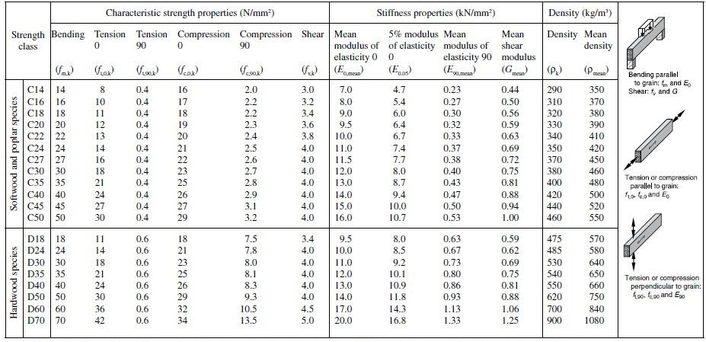

Subscripts used: 0- in direction of grain; 90- across to grain; m- bending, t- tension, c- compression, v-shear; k-characteristic.

Strength class C24 is most used in the construction of wooden frame houses. From previous lesson LU1 it can be found that for structural elements sawn boards with MC no more than 20% and stress grading class at least C24 for load bearing structures and C16 for non-load bearing structures are used.

Mechanical strength grading identifies a physical property that is associated with strength, such as the static or dynamic MOE. Some machines combine judgements on multiple properties, such as density, MOE or inner structure, using x-rays. Therefore, most softwood construction boards are graded based on allowable load resistance, which can be determined from a stress test as non-destructive testing method using:

* mechanically by loading of boards (Fig.1.30.)
* using sound velocity (Fig.1.31.)
* visually - operator or x-ray machines (Fig.1.32.).

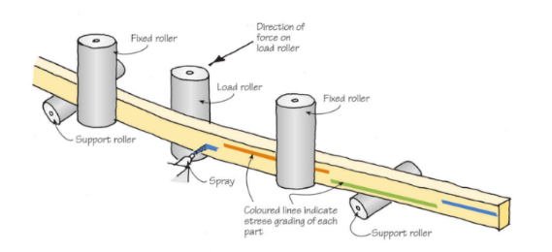 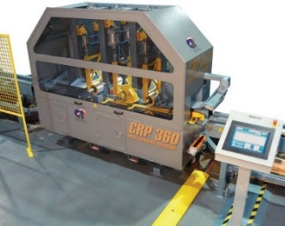

**Fig. 1.30. Stress grading of structural materials[8],[9]**

Simple grading machine is shown in this [video](https://www.youtube.com/watch?v=CfQ_60HuaTQ)[10]

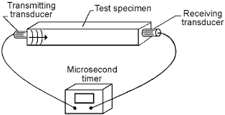 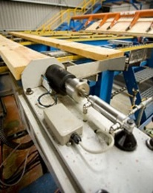

**Fig. 1.31. Grading of structural materials by vibration (sound velocity)[11],[12]**

Or shown in a video produced by [Dynalyse AB Precigrader](http://www.youtube.com/watch?time_continue=25&v=zbpFLABn7cE&feature=emb_logo)[13]

There exist also some mobile equipment produced by [Brookhuis MTG](https://www.youtube.com/watch?v=4FEgRSEq65I&feature=emb_logo)[14]

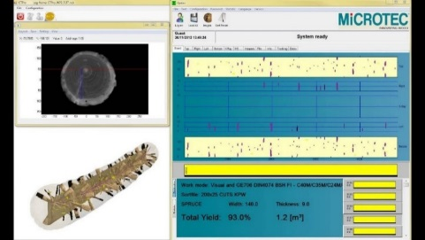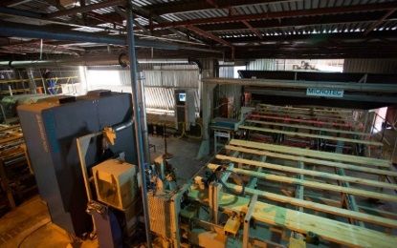

**Fig. 1.32. Grading of structural materials visually and by X-ray scanners (including log scanning)[15]**

Mechanical grading follows the standard EN 14081-1 "Timber structures - Strength graded structural timber with rectangular cross section", which also gives detailed labelling rules - must be CE marked.

Strength of the materials is just one characteristic. The density and MC can also be checked. And the best way to check the quality is to combine - mechanical and visual grading processes.

Innovation for sawing - sorting timber materials is log scanner produced by

* [Microtec CT Log Virtual Grading](https://www.youtube.com/watch?v=U1FyLa6Fm3M)
* [Microtec CT Log 360° X-ray CT-Sawing Optimization](https://www.youtube.com/watch?v=xK4CdNT3DK4)

After the stress grading each board on flat-wise is marked with label (Fig.1.33.).

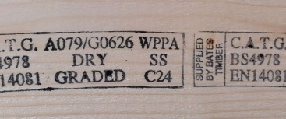

**Fig. 1.33. Example of the board grading[16]**

Label consists of all necessary information: manufacturer name, grading standard, certification body name etc. (Fig.1.33.). On this label it should be marked whether boards are graded wet or dry, because as it is well known lower MC of the boards increase strength of wooden materials.

In Nordic countries standard INSTA 142 rather is used and they are T0; T1; T2; T3 correspondent with EN 338 classes: T0=C14; T1=C18; T2= C24; T3=C30. The manufacturer of the sawn timber can also put its own markings on the pieces of timber. For structural purposes CE marking related to **Construction products** Regulation (EU) No 305/2011 is also mandatory (Fig.1.34.).

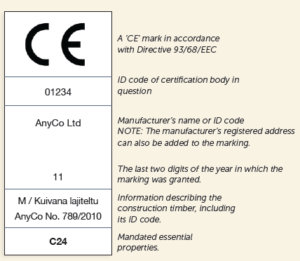

**Fig. 1.34. Marking specification[17]**

## Technological improvement of wood properties

### Improving properties by sawing and planning

One of important things of the structural timber elements are dimensions. For the round/sawn timber requirements for dimensions and volume can be found in standards:

* EN 1309-1 Sawn timber.
* EN 1309-2 Round timber- Requirements for measurement and volume calculation rules.
* EN 336 Structural timber. Sizes, permitted deviations.

Dimensions mean nominal sizes with the MC of the sawn timber (table 1.8.) not more than 20%. The most common lengths of the board vary between 2,7 to 5,4 m in steps of 300 mm.

Table 1.8.

**Most common cross-sectional dimensions for sawn timber[18]**

|  |  |  |  |  |  |  |  |  |  |
| --- | --- | --- | --- | --- | --- | --- | --- | --- | --- |
| Thickness, mm | Width, mm | | | | | | | | |
| 50 | 75 | 100 | 125 | 150 | 175 | 200 | 225 | 250 |
| 191* |  |  | X | O | O |  |  |  |  |
| 222* | JH X | JH X | X | X | X | O | O |  |  |
| 251* | O | O | X | O | O | O | O | O |  |
| 32 |  | O | X | O | O | O | O | O |  |
| 38 |  |  | X | X | O | O | O | O |  |
| 442* |  |  | O | O | O | O | O | O | O |
| 50 |  | JH X | X | X | X | X | X | O |  |
| 63 |  |  | O | O | O | O | O | O |  |
| 75 |  | JH O | O | O | O | O | X | X |  |
| 100 |  |  | X | O | O | O | O | O |  |
| 125 |  |  |  | X |  |  |  |  |  |
| 150 |  |  |  |  | X |  |  |  |  |

1* usually pine; 2* usually spruce; x =standard size; o = rarely produced size; JH- usually done by splitting afterwards, whereby the width is 2 mm less that the nominal size.

The maximum permitted dimensional deviations from nominal sizes for sawn-surface sawn timber are shown in the table 1.9.

Table 1.9.

**Max. permitted dimensional deviation for sawn-surface sawn timber**[19]

|  |  |
| --- | --- |
| Dimension of timber | Dimensional deviation, mm |
| Thickness and width ≤ 100 mm | -1,0 to +3,0 |
| Thickness and width ≥ 100 mm | -2,0 to +4,0 |
| Length when sorted according to length | -25 to +50 |
| Length when cut to the specified size | ±2,0 |

The maximum permitted dimensional deviations from nominal sizes for dimensioned sawn timber are shown in the table 1.10.

Table 1.10.

**Max. permitted dimensional deviation for dimensioned sawn timber**20

|  |  |
| --- | --- |
| Dimension | Dimensional deviation, mm |
| Thickness and width ≤ 100 mm | ±1,0 |
| Thickness and width ≥ 100 mm | ±1,5 |
| Length when sorted according to length | -25 to +50 |
| Length when cut to the specified size | ±2,0 |

Next step of mechanical machining is surface milling. It could be done rough and smooth (Fig.1.35.) In the planning of sawn timber, at least 2 mm is planned from all sides. The result of the planing can be rough – boards might exhibit unplanned areas (Fig.1.35.).

|  |  |
| --- | --- |
| Graphic6 smooth planed surface | Graphic6 rough planed surface |

**Fig. 1.35. Planed sawn material surface characterization.**

For planned materials cross section of the boards is shown in table 1.11.

 Table 1.11.

**Most common cross-sectional dimensions for all-round planed timber**20

|  |  |  |  |  |  |  |  |  |  |  |  |
| --- | --- | --- | --- | --- | --- | --- | --- | --- | --- | --- | --- |
| Thickness, mm | Width, mm | | | | | | | | | | |
| 15 | 21 | 28 | 33 | 45 | 70 | 95 | 120 | 145 | 170 | 195 |
| 8 |  | X |  | X | X | X | X |  |  |  |  |
| 12 |  |  |  | X | X | X | X |  |  |  |  |
| 151* | X |  |  | X | X | X | X | X | X | O |  |
| 182* |  |  |  |  | X | O | X | X | X | O | O |
| 211* |  | X |  |  | X | X | X | X | X | X | X |
| 28 |  |  | X |  | X |  | X | O | O |  |  |
| 33 |  | O |  | X | X | X | X | O | O |  |  |
| 45 |  |  |  | X | X | X | X | X | X | O | X |
| 70 |  |  |  |  |  | X |  |  | O |  | O |

1* usually pine; 2* usually spruce; x =standard size; o = rarely produced size; JH- usually done by splitting afterwards, whereby the width is 2 mm less that the nominal size.

The maximum permitted dimensional deviations from nominal sizes for all-round planned timber are shown in the table 1.12.

Table 1.12.

**Max. permitted dimensional deviation for all-round planed sawn timber**20

|  |  |
| --- | --- |
| Dimension | Dimensional deviation, mm |
| Thickness ≤ 20 mm | ±0,5 |
| Thickness ≥ 20 mm1* | ±1,0 |
| Width ≤ 100 mm | ±1,0 |
| Width ≥ 100 mm | ±1,5 |
| Length when sorted according to length | -25 to +50 |
| Length when cut to the specified size | ±2,0 |

1* The maximum permitted dimensional deviation for thickness in floorboards is always ±0,5 mm

The average values for the actual thickness and width of pieces belonging to a batch of sawn timber cannot, however, be less than the nominal size.

### Improving properties by production of wooden products

For glued laminated timber (GLT), for example, glued in length with finger joint optimal use of higher strength wood material beams in the outer layers (GL32 or GL36) and lower strengths wood (GL24) for inner layers (Fig.1.36.).

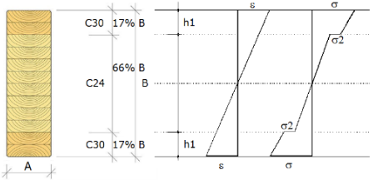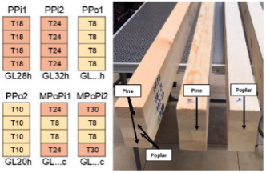 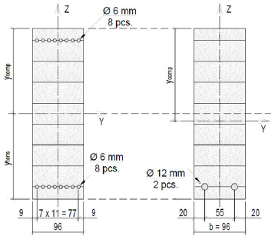



slodze

**Fig. 1.36. GLT strength improvement by sorting**[20],[21], [22]

In this case if the GLT glued from the same strength materials it is homogeneous (h) and marked as GL24h. if from different strength materials it is combined (c) and marked as GL28c. GLT strength properties also can be increased by combining with other materials steel reinforcement (Fig.1.36.).

## Chemical improvement of wood properties

In standard EN 350 guidance on methods for determining-classifying the durability of wood-based materials (heat-treated, preservative treated as well as to modified wood) against biological wood-destroying agents are given. The wood-destroying agents considered to standard (Table 1.13.) are:

* wood-decaying fungi (basidiomycete and soft-rot fungi);
* beetles capable of attacking dry wood;
* termites;
* marine organisms capable of attacking wood in service.

Table 1.13.

#### Different Use Classes and Occurrence of Biological Agents

| **Use**  **Class** | **Definition** | **General Service Conditions** | **Occurrence of Biological Agents** | | | | |
| --- | --- | --- | --- | --- | --- | --- | --- |
| **Disfiguring fungi** | **Wood-destroying fungi** | **Beetles** | **Termites** | **Marine borers** |
| 1 | Situation in which the wood-based product is inside a construction, not exposed to the weather and wetting. | Interior, dry | – | – | Everywhere in Europe & EU territories | Locally present in Europe | – |
| 2 | Situation in which the wood-based product is under cover and not exposed to the weather (particularly rain and driven rain) but not persistent, wetting can occur. | Interior, or under cover, not exposed to the weather. Possibility of water condensation. | Everywhere in Europe | | | Locally present in Europe | – |
| 3 | Situation in which the wood-based product is above ground and exposed to the weather (particularly rain)2* | Exterior, above ground, exposed to the weather. | Everywhere in Europe | | | Locally present in Europe | – |
| When sub-divided: 3.1 Limited wetting conditions 3.2 Prolonged wetting conditions |
| 4 | Situation in which the wood-based product is in direct contact with ground and/or fresh water3* | Exterior in ground contact and/or fresh water. | Everywhere in Europe | | | Locally present in Europe | – |
| 5 | Situation in which the wood-based product is permanently or regularly submerged (i.e. sea water and brackish water). | Permanently or regularly submerged in salt water | Everywhere in Europe4* | | | Everywhere in Europe4 | Everywhere in Europe |

**Notes:**

1* It may not be necessary to protect against all biological agents listed as they may not be present or economically significant in all service conditions in all geographical regions, or may not be able to attack some wood-based products due to the specific constitution of the product. 2* Decay risk depends on the climate and other in-use conditions (temperature, relative humidity, structural conditions, design details and maintenance provisions). 3* Wood-based products which are constantly below water level or completely buried and fully saturated by water are not susceptible to be attacked by fungi but may be damaged by bacterial decay. 4* The above water portion of certain components can be exposed to all the above biological agents.

In the following table 1.14. application by wooden elements is given.

Table 1.14.

**Timber use classes**

|  |  |
| --- | --- |
| Wooden component | Use class |
| Roof timber (dry) | 1 |
| Roof timber (risk of wetting) | 2 |
| Tiling battens | 2 |
| Timber frame components – except sole plates | 2 |
| Frame sheeting – plywood’s | 2 |
| External cladding | 3.2 |
| Battens for external cladding | 2 |
| Firstfloor joists | 1 |
| Ground floor joists | 2 |
| External joinery | 3.1 |
| External doors | 3.1 |
| Decking out of ground contact | 3.2 |
| Decking in ground contact | 4 |
| Fence posts | 4 |
| Fence panels | 3.2 |
| Garden products – water contact | 4 |

The standard EN 350 lists the natural durability of selected wood species (against wood-destroying fungi, dry wood-destroying beetles, termites and wood pests in sea water) are shown. Natural durability against wood-destroying fungi is categorised in five durability classes (DC):1- highly durable; 2– durable; 3- moderately durable; 4- slightly durable;5- non-durable.

Different species of trees have different resistance to biodegraders. Softwood heartwood contains more extracts and other components, making it more durable for the sapwood. From European hardwoods oak and some species of larch in Europe are durable. For example, naturally durable wood in contact with the soil will last from 10 to 12 years, but moderately durable or low-tolerant - from 5 to 8 years, non-durable - less than 3 years. Wood service life will also depend on the dimensions of the structure. Structures with a larger cross-section will retain its functions longer. Younger trees are also less durable. In table 1.15. common used softwood durability classes are given depending of heartwood and sapwood.

Table 1.15.

#### Durability by wood species

|  |  |  |
| --- | --- | --- |
| Wood type | Heartwood | Sapwood |
| Fir | 4 | 5 |
| Larch | 3-4 | 5 |
| Spruce | 4 | 5 |
| Pine | 3-4 | 5 |
| European oak | 2-4 | 4 |
| Teak | 1-3 | - |

The treatability of the various wood types has an important role to play, particularly for the impregnation of timbers in the vacuum pressure process or the double vacuum process. In the EN 350 standard the treatability of the various wood types is also listed (table 1.16.). There are altogether 4 treatability classes

Table 1.16.

**Classification of the treatability of wood**

|  |  |  |
| --- | --- | --- |
| Treatability  Class | Description1* | Explanation |
| 1 | Easy to treat | Easy to treat; sawn timber can be penetrated completely by pressure treatment. |
| 2 | Moderately easy to treat | Fairly easy to treat; usually, complete penetration is not possible, but after 3 or 4 hours by pressure treatment more than 6 mm lateral penetration can be reached in softwoods and in hardwoods a large proportion of the vessels will be penetrated. |
| 3 | Difficult to treat | Difficult to treat; 3 – 4 hours by pressure treatment may not result in more than 3 mm to 6 mm lateral penetration. |
| 4 | Extremely difficult to treat | Virtually impervious to treatment; little preservative absorbed even after 3 – 4 hours by pressure treatment; both lateral and longitudinal penetration minimal. |

**Note:**Historically treatability data may use other descriptive terms which approximate to the treatability classes as follows: Class 1*   Permeable; Class 2   Moderately resistant; Class 3   Resistant; Class 4   Extremely resistant.

In the vacuum pressure process, mainly softwoods are treated, some of which have very different treatability levels (table 1.17.).

Table 1.17.

#### Treatability classes by wood species

|  |  |  |
| --- | --- | --- |
| Wood type (softwoods) | Heartwood | Sapwood |
| Douglas fir | 3-4 | 2-3 |
| Fir | 2-3 | 2 |
| Pine | 3 | 1 |
| Spruce | 3-4 | 3 |

The aim of chemical protection of wood is to improve the durability of wood with active biocides chemical compounds that destroy or inhibit the development of living organisms.

There are two types of chemical protection:

* preventive - to prevent or modify wood in the conditions of prolonged wetting its resistance to wood damages;
* corrective - to actively control damages that have already been introduced into the wood (broken during repair, replaced with a new one, previously treated).

When using preventive chemical protection techniques, constructive protection is also important. Construction errors are mostly impossible to compensate with chemical protection techniques.

### Industrial wood preservatives

Wood preservatives are active substances (biocides) or compositions containing them intended for wood for the preventive protection. Biocides can be inorganic (metal salts, oxides) or organic compounds dissolved in water. Basic requirements for wood preservatives – must:

* be toxic to fungi, insects and marine organisms;
* not have any undesirable properties during use;
* not be corrosive;
* be cheap.

*Inorganic preservatives* are water-soluble preservatives are the most widely used, they are individual inorganic compounds (boric acid, boron, fluorine, copper salts) or combined preparations containing chromium, copper, arsenic, boron, fluorine, zinc compounds. In recent years, the use of chromium - free preparations, which combines with water-soluble organic and inorganic compounds.

*Organic preservatives* contain active substances (organotin compounds, naphthenates, pentachlorophenol etc.) dissolved in organic solvents (e.g. white spirit). This chemical use provides long-term protection (insoluble in water). Organic preparations are mainly used in the restoration of buildings, so that no additional moisture is brought into the wood during repairs.

One of *oily protective materials* iscreosote - the oldest commercial preservative produced from nature substances rich in carbon (coal, lignite, wood) by heating without air (pyrolysis). Carboline (anthracene oil) is a tar oil impregnated in wood under pressure, applied with a brush or immersed, however, infiltration is limited. Lignite oil is tar oil from lignite. Shale oil is obtained by distilling bituminous shale tar. It is used for impregnation of track sleepers.

### Wood preservatives treatment process

The wood is placed in a metal autoclave with a wood preservative. Increasing pressure, chemicals are fed into the wood (Fig.1.37.). The process involves placing the timber within the treatment cylinder and creating an initial vacuum within the timber cells. Hydraulic pressure is then applied forcing the preservative deep into the timber cells. After a pre-determined period of pressure depending on the species of timber being treated and its eventual use, the treatment solution is pumped back into storage and a final vacuum extracts any excess treatment solution from the timber.

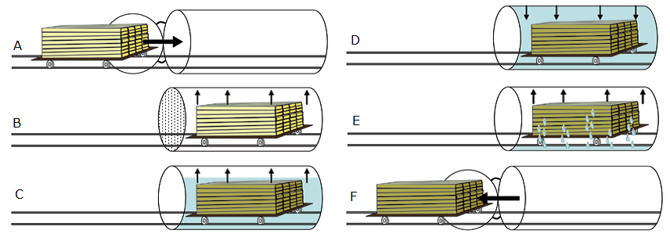

**Fig. 1.37. Typical steps in pressure treating process** (Wood Hanbook, 2010): A – untreated wood is placed in cylinder; B - a vacuum is applied; C - the wood is immersed in solution (still under vacuum); D - pressure is applied; E - preservative is pumped out, and a final vacuum; F - the wood is removed from the cylinder.

These types of vacuum, high pressure treatments are particularly relevant for UC 1 to 4 (service life protection from 15 to 60 years). **In practice double vacuum, low pressure treatments also** can be used for building and joinery timbers in UC 1, 2 and 3 (service life protection 30 to 60 year). Treatment provides an effective envelope protection around the timber and leaves the colour of the timber virtually unchanged. A colour indicator, as well as water-repellence, can be added to the treatment if required. *Protim Osmose* is one of many manufacturers that provide the treatments for these double vacuum plants. Advantages of pressure treatment compared to non-pressure methods:

* deep, even absorption;
* precise control of the amount injected;
* faster and safer process.

### Non-pressure methods

Non-pressure methods include surface treatment: brushing, spraying, dipping, cold impregnation, hot and cold baths (thermal process), diffusion and protective equipment bandages. The methods differ in the depth of absorption of the solution and the amount absorbed. Penetration into the wood is about 1 to 3 mm.

There are many manufacturers that offer treatments of this type. These are superficial treatments, and they are less effective than the pressure treatment options. The advantages are that are easy to apply and cost effective.

There is some examples for chemical improvement of wood properties.

***Acetylated wood***

The term "chemical modification of wood" was first used by Tarkov in 1946 to denote it covalent attachment of chemical groups to any of the cell wall polymers corresponding to today's understanding of chemical modification (R. Rowell, 2014). Only acetylation of wood with acetic anhydride has to industrial realization in this century. In the late eighties and early 90s in Switzerland issued patents for the acetylation of radial pine (*Pinus radianta*) with the product mark *Accoya*® (Fig.1.38.).

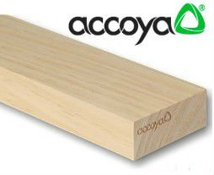 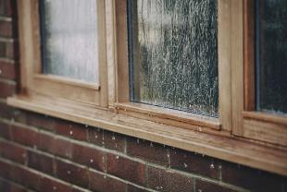

**Fig. 1.38. Accoya® wood product and example of use[23]**

*Accoya* brings unprecedented reliability for timber, it is manufactured and tested not to visibly swell, shrink or distort. *Accoya* are used for windows, decking and cladding production.

The use of acetylation residue wood product developed by engineers and nowadays is called *Triccoya*® (Fig.1.39.).

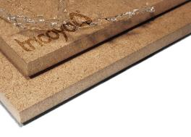 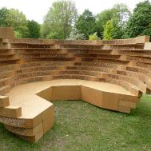

**Fig. 1.39. Triccoya® wood based panels and example of use[24]**

## Thermal protection of wood

Wood thermal modification (WTM) is a heterogeneous process in which a solid wood interacts with a liquid or gaseous reagent. Therefore, timber modification differs from its realization with solid wood, particles or fibers.

One of the perspective directions have to have an effect on wood with elevated temperature and humidity is wood hydrothermal (WHT) or a combination with mechanical action - hydrothermal-mechanical (WHTM) thermal modification. The main objectives of WTM in general are:

* reduce its swelling/shrinkage in environments with variable humidity;
* reduce the internal stresses in the wood to facilitate further processing;
* increase resistance to biodegradation (D. Sandberg, A. Kutnar, 2016).

Change of wood properties and technological solutions with WHT summarized in Figure 1.40.

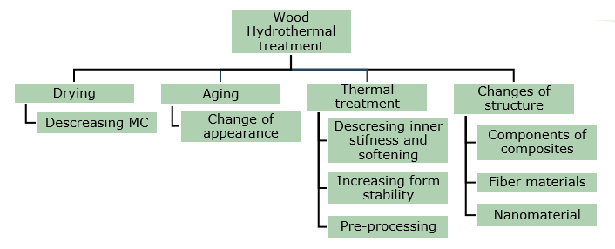

**Fig. 1.40. Wood Hydrothermal process** (Sandberg and Kutnar, 2016).

WTM is essentially a chemical process, as it changes both the composition of the wood and its chemical and physical properties. WTM is mainly broken down by hemicellulose. Change of wood properties and technological solutions with WHT or WHTM summarized in figure 1.40. and 1.41. WTM uses a variety of technological solutions for the effect of heat on wood in an oxygen-free environment: vacuum, inert gas or water vapour the environment. Some WTM methods use oil to promote heat transfer to the wood and remove oxygen impact (Sandberg and Kutnar, 2016). Table 1.18. shows the difference in above mentioned processes.

Table 1.18.

**Wood thermal modification processes** (Sandberg un A. Kutnar, 2016)

|  |  |  |  |  |
| --- | --- | --- | --- | --- |
| Process | Temperature of modification, °C | Time of process, h | WTM environment | WTM happens |
| FWD | 120–180 | 12–15 | Heat | Closed system |
| Plato | 150–190 | 70–120 | Saturated steam and after then heated air | A four-step process |
| ThermoWood | 185–215 | 30–70 | Steam flow | In an open system |
| Le Bois Perdure | 200–230 | 12–36 | Heat | In an open system |
| Retification | 160–240 | 8–24 | N or other inert gas flow, 02 content ≤ 2% | In an open system |
| OHT | 180–220 | 24–36 | Vegetable oil | Closed system |
| TERMOVUOTO | 160–220 | ≤ 25 | Vacuum | In an open system |

WTM significantly changes the binding, maturation and shrinkage of wood water, biodegradation, mechanical properties, appearance, odor, adhesion to adhesives and coatings. Change in the main properties of wood WTM:

* lower bending strength by 30 to 50% and a slight change in modulus of elasticity compared to with wood before modification;
* wood is more brittle after WTM;
* it has lower abrasion resistance and hardness.
* distinct brown colour;
* wood has a specific smoke-like odor;
* Its biological safety is still debatable.

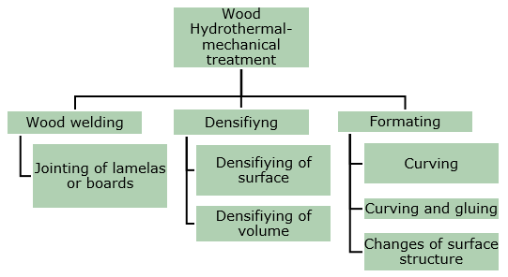

**Fig. 1.41. Wood Hydrothermal-mechanical process** (Sandberg and Kutnar, 2016).

## Operational improvement of wood properties

### Protection by surface covering

The purpose of this type of protection is to protect the wood from excessive, prolonged wetting. One of the solutions is surface treatment with materials - oils, varnishes, which reduce water absorption. The treatment with hydrophobic (water repellent) agents is performed on a dry surface of the material or the wet wood surface is treated to allow the wood to dry. Coatings that form a dense film are not suitable for solid wood structures, such as log buildings. Atmospheric conditions cause the wood to shrink and swell, changing size and at the same time damaging the less flexible coating. It forms microcracks in covered material, into which fungi enter and begin to grow, especially mold and bruising, spores. The coating peels off, staining appears on the wood surface. Damage to rot fungi due to improper decoration is formed by wood window corner joints. They can damage the wood over time, destroying its structure.

Varnishes and glazes are used for surface treatment. They mainly have a decorative function. Compositions with special additives also have protection against ultraviolet radiation, which allows for longer storage the yellow tone of fresh wood and slow down the appearance of wood bruising.

***Lazurs*** are transparent coatings with open pores. If they contain light resistant pigments fine, solid particles finely dispersed in a binder and solvent, then simultaneously on the surface protects against both moisture and ultraviolet radiation and at the same time allows wood to evaporate excess moisture. Lazurs are based on organic solvents or water.   
***Varnishes*** are solutions of film-forming organic substances to improve the surface properties of materials (improvement of appearance, protection against humidity and weathering). Varnishes contain additives: softeners, drying accelerators, pigments. Varnishes protect wood from physical factors and small mechanical damage.

***Oils and waxes***first protect the wood surface from physical exposure, such as stains, dirt, dust and scratches. Correctly selected product and treated accordingly improves the surface properties of wood, prevents wetting, while not interfering with the wood to breathe. Oils are a good product that improves and preserves the decorative properties of wood.

### Protection by structure covering

Wood is relatively resistant to aggressive chemical compounds in the atmosphere and ultraviolet radiation. It begins to degrade when exposed to moisture for a long time, while transient moisture in the wood does not damage. The most important precondition for protecting wood from the effects of fungi is to provide it wood moisture, which is insufficient for fungi growth. The most important thing to achieve this goal is constructive protection aimed at preventing or reducing by constructive means moisture infiltration into the wood. It is important to prevent wood from getting wet during the construction process. Constructive measures to be taken already during the design of the building are:

* wide roof overhangs to protect wooden walls from direct rain;
* properly designed cladding that facilitates water drainage and under which ventilation is provided;
* high foundations (at least 50 cm above ground level) to prevent wood from getting wet with bounced water drops.

More about how to protect wood structure elements from wetting is given in next LU2-4.

## Wood degrading microorganisms

### Wood fungi

Wood-degrading fungi are caused by wood rot. As a result of wood decomposition, there is a loss of weight and strength. There are three main groups according to the type of wood decomposition: brown rot (Fig.1.42.), white rot, (Fig.1.43.), and soft rot (Fig.1.44.).Brown rot or destructive rot is a type of wood damage that includes wood - hemicellulose and cellulose to water-soluble sugars. It is characterized by rapid decrease of wood strength.

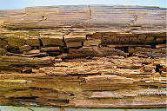

**Fig. 1.42. Brown rot** (Morozovs et.al., 2018)

White rot (corrosive rot) (Fig.1.43.) is a type of wood damage that includes lignin, hemicellulose and cellulose degradation. The white rot is characteristic of hardwoods.

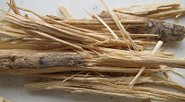

**Fig. 1.43. White rot** (Morozovs et.al., 2018)

Soft rot (Fig.1.44.) is a type of wood damage where cellulose and hemicellulose are broken down, while lignin is degraded to a limited extent. Damaged wood of the soft rot becomes greyish and soft (Fig.1.44.). At drying process wood splits, forming prismatic shapes. In buildings, soft rot damage is affected window elements, where from the outside it is formed under the influence of rain, but from the inside as a result of water condensation.

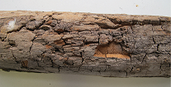

**Fig. 1.44. Soft rot** (Morozovs et.al., 2018)

### Wood colouring fungi

Staining fungi endanger the wood throughout its life - both immediately after sawing and drying, both when the wood is re-wetted during operation.Blue stain fungi cause the stains to discolour wood with a high MC. Blue stain does not develop on water – stored wood or in wood with a MC below 20%. Fungi produce a blue or grey-black colour, mainly by damaging softwoods. Usually develops only in the sapwood. These fungi decrease decorative appearance and reduces the value of the material. Blue stain is divided into primary and secondary development. Primary blue stain is formed on freshly sawn tree trunks in the forest and sawn timber (Fig.1.45.).

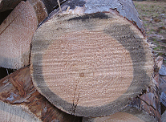

**Fig. 1.45. Primary blue stain on freshly sawn tree trunks in the forest** (Morozovs et.al., 2018)

Optimal growth conditions for blue stain are:

* wood moisture 50 to 100%. The MC of the wood after felling is 120 to 180%, but this decreases rapidly, so the tree becomes easily accessible for blue stain;
* the temperature is 22 to 29 °C. In nature, growth continues up to +5 °C. fungi do not grow at a temperature higher than 37 °C.

Blue stain of sawn timber occurs in storage areas after sawing logs to insufficient dried as well as tightly stacked boards, beams, etc.).

Secondary blue stain occurs in wood built into buildings, painted and/or varnished, if the wood is re-moistened. Fungi grows through or lifts the lacquer cover (Fig.1.46.).

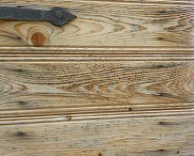

**Fig. 1.46. Secondary blue stain in built-in wood (doors)** (Morozovs et.al., 2018)

### Mold

Mold (Fig.1.47.) is found on softwoods and hardwoods as well. In buildings, mold is common on wet, fresh wood (for autumn and winter constructions). Mold is mainly on or near the surface (usually not deeper than 0,5 mm).

Optimal mold growth conditions:

* wood moisture 28 to 32%;
* temperature 20 to 30 °C.

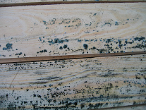

**Fig. 1.47. Mold on a wet wood surface** (Morozovs et.al., 2018)

Mold can be washed or planed. Green wood should be dried or treated as soon as possible to avoid wood mold with a suitable fungicide. Fungi reduce properties of wood. Effect of decay on properties (Table 1.19.) shows expected strength losses in wood that has been partially destroyed by decay. The table is for softwoods only and for just one type of decay.

Table 1.19.

**Probable Strength of Wood in Early Stage of Decay (5 to 10%)**

|  |  |
| --- | --- |
| Strength property | Probable Remaining strength (% of original strength) |
| Static bending | 30 |
| Impact bending | 20 |
| Modulus of Elasticity | 30 |
| Compression parallel to grain | 55 |
| Tension parallel to grain | 40 |
| Compression perpendicular to grain | 40 |
| Shear | 80 |

# LIST OF REFERENCES

1. **EN 335:2013   Durability of wood and wood-based products – Use classes: definitions, application to solid wood and wood-based products**
2. EN 350:2016 Durability of wood and wood-based products – Testing and classification of the durability to biological agents of wood and wood-based materials
3. EN 975-1:2009 Sawn timber - Appearance grading of hardwoods - Part 1: Oak and beech is used.
4. EN 1912 "Structural Timber. Strength classes. Assignment of visual grades and species"
5. Hill C.A.S. Wood Modification. Chichester: John Wiley & Sons, Ltd, 2006. 239 p.
6. Hoadley R.B. Understanding Wood: A Craftsman's Guide to Wood Technology. The Taunton Press, 2000. 288 p.
7. Porteous J., Kermani A. Structural Timber Design to Eurocode 5 (Second edition). 2013., Willey-Blackwell, 640 p.
8. Porter T. Wood identification and Use. GMC Publications, 2007., 288 p.
9. Rowell R.M. Handbook of wood chemistry and wood composites. London: Taylor&Francis group, London, 2005. 487 p.
10. Niemz P. and Sonderegger W. U. Holzphysik: Physik des Holzes und der Holzwerkstoffe. Carl Hanser Verlag GmbH & Co. 2017., 580 p.
11. Morozovs A., Irbe I., Bukšāns E. Chemical processing and protection of wood (Koksnes ķīmiskā pārstrāde un aizsardzība. In Latvia), Avots, Rīga, 2018., 171 p.
12. Sandberg D., and Kutnar A. Thermally modified timber: recent developments in Europe and North America. Wood and Fiber Science 48(1), 2016., 28-39 pp.Wagenführ A. Scholz F. Taschenbuch der Holztechnik. Carl Hanser Verlag GmbH & Co. 2018., 567 p.

1. <https://www.mdpi.com/2079-6412/10/7/629/htm>
2. <https://www.swedishwood.com/wood-facts/about-wood/wood-grades/>
3. <https://www.swedishwood.com/wood-facts/about-wood/wood-grades/>
4. <https://www.youtube.com/watch?v=NoFex15PE1Y>
5. <https://www.youtube.com/watch?v=iPoaGcyQ3us&feature=emb_logo>
6. <https://www.youtube.com/watch?v=qFwOcHbJats>
7. <https://www.woodproducts.fi/content/quality-classes-names-and-dimensions>
8. <https://www.buildmagazine.org.nz/index.php/articles/show/whats-behind-timber-strength-and-stiffness>;
9. <http://www.conceptionrp.com/product/crp-360/>
10. <https://www.youtube.com/watch?v=CfQ_60HuaTQ>
11. <http://falconengineeringusa.com/grading.html>
12. <https://fpl.fs.fed.us>
13. [www.youtube.com/watch?time_continue=25&v=zbpFLABn7cE&feature=emb_logo](http://www.youtube.com/watch?time_continue=25&v=zbpFLABn7cE&feature=emb_logo)
14. <https://www.youtube.com/watch?v=4FEgRSEq65I&feature=emb_logo>
15. <https://microtec.eu/en/solutions/all-solutions/south-africa-fully-featured-goldeneye-706/>
16. <https://www.batestimber.co.uk/timber-services/>
17. <https://www.woodproducts.fi>
18. <https://www.woodproducts.fi/content/standard-sizes-thicknesses-widths-and-lengths>
19. <https://www.woodproducts.fi/content/permitted-dimensional-deviations>

    20 <https://www.swedishwood.com/building-with-wood/about-glulam/choosing_glulam/>
20. <https://www.swedishwood.com/building-with-wood/about-glulam/choosing_glulam/>
21. <https://www.mdpi.com/1996-1944/13/14/3134/htm>
22. <https://iopscience.iop.org/article/10.1088/1757-899X/251/1/012104>
23. <https://www.accoya.com/uk/>
24. <https://tricoya.com/>