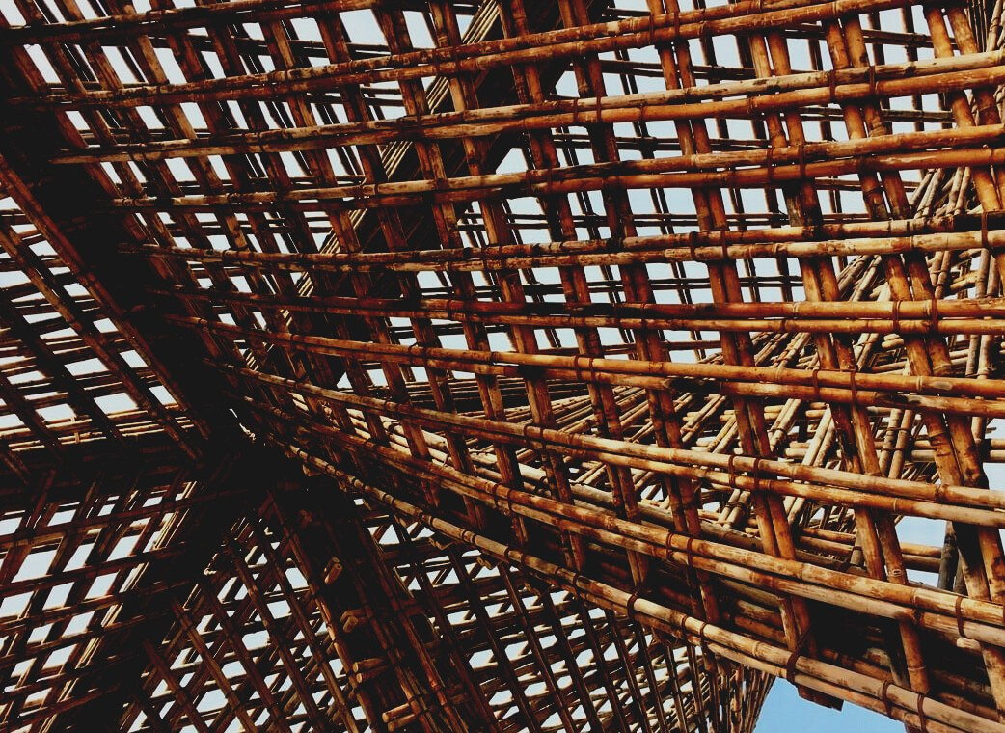

ASSESSMENT MATERIAL

Learning Unit 2
PERFORMANCE AND DURABILITY OF WOODEN STRUCTURES
UPWOOD
Up-skilling construction workers in wood construction methods for energy-efficient buildings

UPWOOD-PUU
Rakennustyöläisten ammattitaito energiatehokkaiden rakennusten puurakentamisenmenetelmissä

UPWOOD
Rakennustyöläisten ammattitaito energiatehokkaiden rakennusten puurakentamisenmenetelmissä

UPWOOD-PUU
Rakennustyöläisten ammattitaito energiatehokkaiden rakennusten puurakentamisenmenetelmissä

Table of contents
1. Frequently asked questions 2
2. Multiple choice questions 3
3. Case studies 3
3.1 Case study 1 3

Frequently asked questions
Question: What factors affect the durability of a wooden structure?
Answer: Water as well as weather conditions such as sunshine, wind, or rain.
Question: What is meant by hygroscopicity?
Answer: Wood strives for equilibrium moisture with the surrounding moisture.
Question: What does Dew Point Mean?
Answer: At the dew point, water vapor condenses into water.
Question: What is absolute and relative humidity?
Answer: Absolute humidity means the amount of water in a tree, for example. The relative humidity is the amount of water vapor relative to temperature.

Multiple choice questions
- The strength of wood is better
  - in a perpendicular direction against of grains
  - in the direction of grains
- Both tensile and compressive strength of the wood depends
  - on the direction of grains and possible defects of the wood
  - only on the species of tree
  - on the number of branches
- Wooden beams are usually dimensioned according to the
  - maximum allowable deflection
  - breaking strength
- Facades are particularly exposed to the sun, wind and sloping rain
  - on the east and north walls of the building
  - on the coasts, south, the southwest and west walls of building

Case studies

Case study 1
For load-bearing structures it is important to choose the best beams to avoid vibration. In both, sub floor and upper floor structures beams may be i.e. solid sawn timber beams, glulam or veneer beams. Describe what timber products would you use to minimize deflection and vibration in sub floor and upper floor structures. Justify what are the essential factors to consider while selecting the best beams from the wood batch.

