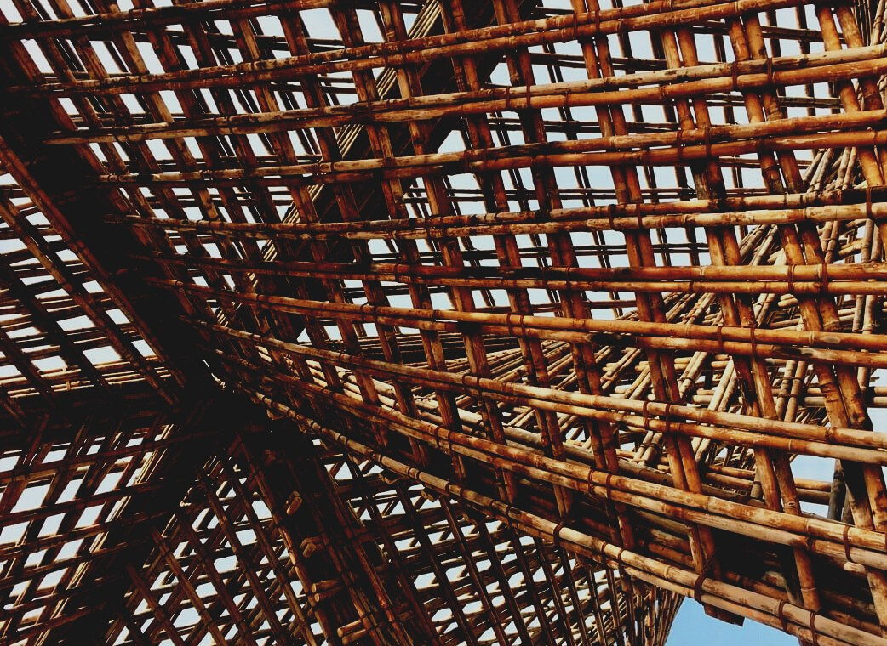

TRAINING MATERIAL

Learning Unit 2
CONNECTORS AND ADHESIVES
UPWOOD
Up-skilling construction workers in wood construction methods for energy-efficient buildings

UPWOOD-PUU
Rakennustyöläisten ammattitaito energiatehokkaiden rakennusten puurakentamisenmenetelmissä

UPWOOD
Rakennustyöläisten ammattitaito energiatehokkaiden rakennusten puurakentamisenmenetelmissä

UPWOOD-PUU
Rakennustyöläisten ammattitaito energiatehokkaiden rakennusten puurakentamisenmenetelmissä

UPWOOD
Rakennustyöläisten ammattitaito energiatehokkaiden rakennusten puurakentamisenmenetelmissä

UPWOOD-PUU
Rakennustyöläisten ammattitaito energiatehokkaiden rakennusten puurakentamisenmenetelmissä

UPWOOD
Rakennustyöläisten ammattitaito energiatehokkaiden rakennusten puurakentamisenmenetelmissä

UPWOOD-PUU
Rakennustyöläisten ammattitaito energiatehokkaiden rakennusten puurakentamisenmenetelmissä

Table of contents
1. Starting point 2
2. Wooden joints 3
3. Fasteners 4
4.1. Screws, bolts and nails 5
4. Adhesives 6
4.1 Different adhesives 7
4.2 Adhesive seam 7
5. Other fasteners 8
6. List of references 10

Starting point
Joints used in buildings are divided into adhesive joints and mechanical joints. Joints in old buildings are usually contact joints where the compressive force is transferred from one wooden surface to another through contact, and the function of the fastener is to hold the pieces to be joined in place. In light wooden structures, the most common connection method is a nail or screw connection. In heavy structures, e.g. metal form fasteners and beam shoes.
The joining techniques between two pieces of wood are always selected according to the requirements, the properties of the wood used, and the properties of the joints. Attention is paid to e.g. strength, flexibility, toughness, and appearance. The need for use and the type and amount of stress on the joints are key criteria in the selection.
The need to simplify connections (for economic reasons) has introduced easy-to-perform but workable solutions. New computer-controlled CNC and robot technology has made it possible to manufacture more complex wood and fastener joints.

Wooden joints
Dozer joint  The end of the piece is attached directly to the surface of the counterpart and secured by nailing and any nailing plate. | 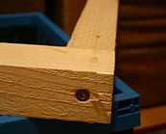
Drill pin connection  Dozer joint reinforced with drill pins. | 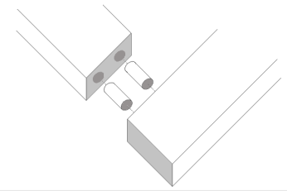
Angle joint  The joint surfaces are at a 45-degree angle. Drill pins can be used as connectors. | 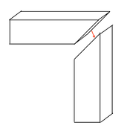
Finger joint  The large adhesive surface provides durability. | 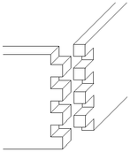
Dovetail joint  Improved, the self-locking shape of the finger joint. Pins made at the end of the piece attach to oblique notches made at the end of the piece. | 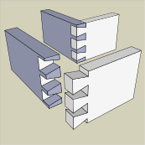
Groove joint  Quite a weak joint, but useful for shelving, for example. | 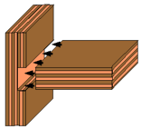
Notch or pin connection  The pin of the piece fits into the notch of the counterpart. The strongest way to connect perpendicular pieces. | 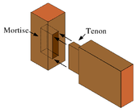
Hook or shoulder joint  The hook joint and its variants are used especially in various frame and log structures. | 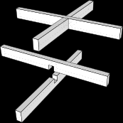

Fasteners
Fasteners (bolts and nuts) shall meet all applicable mechanical and physical properties at ambient temperature, regardless of which tests were performed during production or final inspection. ISO 68-1, ISO 261, ISO 262, ISO 965-1, ISO 965-2, and ISO 965-4 apply to fasteners. The standards do not apply to threaded fasteners that are not tightened. In addition, the standard specifies requirements for properties such as weldability, corrosion or shear stress resistance, torque and clamping force, and fatigue resistance.

Screws, bolts and nails
Frame, furniture and collet screws
Cutter screws | 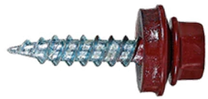
Gypsum board and toothpick screws
Flat cap, plate and drill bit screws | 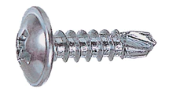
Brass screws
Tape screws | 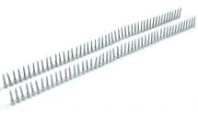
Stainless universal screws
Terrace screws
Universal screws
Nails
Bolts

Adhesives
Wood is rarely made into an object that would be a single piece of wood because the piece of wood lives according to moisture and is not as strong in all directions, which is why wooden objects are always assembled from several pieces with joints. Adhesive joints are affected by the quality of the adhesives, the surfaces to be bonded, and the adhesive surface area. The more adhesive surface area, the stronger the joint. Today, adhesives correspond to the strength of wood, so joints can be made simpler than before.
Wood welding is a method that replaces gluing. In it, two pieces of wood are rubbed together very vigorously for a while, causing them to heat up due to friction. As a result, the ends of the cellulosic fibers open and can adhere to similar cellulosic fibers of the mating piece. Deciduous trees form a bond that corresponds in strength to gluing, but the bond does not withstand moisture. In conifers, such a joint is weak. Some very light snowboards use a core made of welded wood, i.e. the inner layer.
The choice of adhesive must consider the conditions under which the finished adhesive joint is used.
Roughly, adhesives can be divided into three groups according to durability:
- Weatherproof adhesives; adhesives must be more durable than wood in all conditions. The seam must be able to withstand weather conditions, cooking, and micro organisms. These requirements are met by phenolic and resorcinol adhesives and their mixtures.
- Moisture resistant adhesives; adhesives are suitable for indoor use where the relative humidity may be quite high. This group includes melamine adhesives, as well as some urea adhesives and PVAc adhesives.
- Adhesives suitable for indoor use; adhesives do not withstand water soaking and will last for a limited time in humid conditions. The most widely used wood adhesives, urea, and PVAc adhesives belong to this group.

Different adhesives
- Amino adhesives: Used when the adhesive joint is required to be colorless (e.g., plywood).
- Urea adhesives: The most widely used wood adhesives
- Melamine adhesives: Used only in coating films, chipboard manufacturing, and wood construction adhesives.
- Phenol adhesives or phenol-formaldehyde adhesives: Used in the plywood and glue beam industry as a high-frequency adhesive.
- Resorcinol adhesives: Suitable for demanding applications such as load-bearing structures.
- Dispersion adhesives: Frost-resistant aqueous dispersions of thermoplastics.
- Polyurethane adhesives: Classified into 4 main types, the most common being two- and one-component reaction adhesives, solvent adhesives, and aqueous dispersion adhesives.
- Epoxy adhesives: Used for gluing wood and metal and repairing wood structures. Also, glue oily wood such as teak.
- Contact adhesives: Suitable for almost all materials and provide a flexible and waterproof adhesive joint.
- Natural glue: For example, the use of glue made from milk in gluing wood has been known for thousands of years.

Adhesive seam
Gluing creates an adhesive joint between the pieces to be glued, the success of which requires sufficient penetration and adhesion of the adhesive to the wood. This phenomenon is called adhesion. Cohesion, in turn, means the internal strength of the adhesive and the adhesive joint.
The adhesive joint is as strong as the material to be glued, such as wood. The strength of the adhesive joint is usually determined by the adhesion of the adhesive to the wood. In addition to adhesion, the adhesive joint is affected by mechanical adhesion, which occurs when the adhesive penetrates the pores of the wood and binds there when it dries.

Other fasteners
Beam shoes
Selected according to the joint requirement.
Log brackets  Used for log and wood construction. | 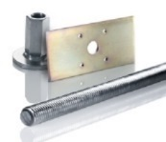
Extension plates  Used for splices. | 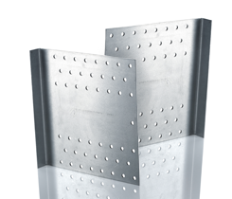
Support plates  Used for beam joints. | 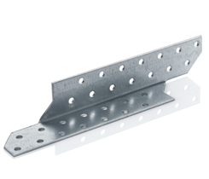
Corner plates  Used for construction joints. | 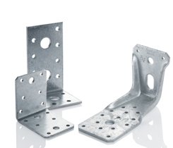
Corner support  Used for construction beam joints. | 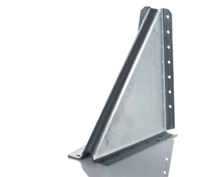
Board bracket  Used for construction support joints. | 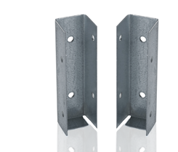
Nailing plates  For all construction, installed with CE-marked anchor bolts or anchor nails. | 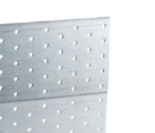
Pillar shoes  Used mainly for load-bearing structures. | 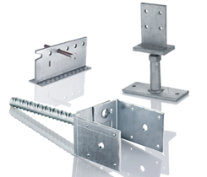
Screw piles  Suitable for underground construction. | 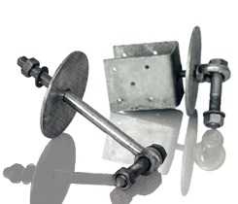
Hole rim  Suitable for all types of construction and support of structures. | 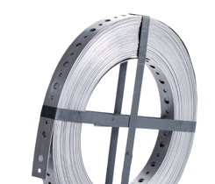
Steel dowels  Used with concealed shoes. | 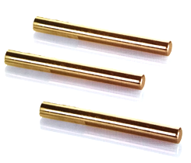
U-shoe  Installed directly on wood or concrete. | 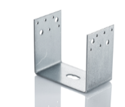
Universal plate  Supports intersecting beam joints installed crosswise on opposite sides of the joint. | 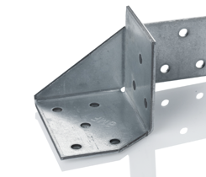
Bulldog plates  Between two wooden surfaces a wood binding board. | 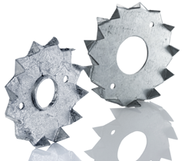
Fork plate  For making intersecting wooden joints. | 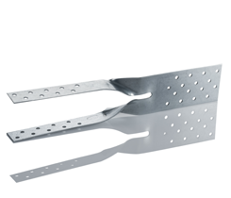
Concrete adhesion  Suitable for supporting concrete / wood joints, installation in concrete with anchor / concrete screw. | 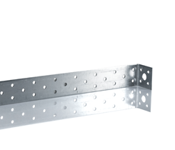

List of references
Finland’s Ministry of the Environment website [referred 15.11.2020]. Available: https://ym.fi/rakennustuotteet
MiTek Finland Oy website [referred 15.11.2020]. Available: https://www.mitek.fi/
Puuproffa website [referred 15.11.2020]. Available: https://puuproffa.fi/
Puuinfo website [referred 15.11.2020]. Available: https://puuinfo.fi/
SWM Wood website [referred 15.11.2020]. Available: https://www.swm-wood.com/en/
Vuotilainen, M., Möttönen, J., Luostarinen, K., Haapala, A., Kiilunen, R., Etelä, R. & Laitinen, E. Metsästä tuotteeksi, Puualan perusteet. 2018. Juvenes Print – Suomen Yliopistopaino Oy.
RT 42-10643. Puuovet. 1997. Helsinki: Rakennustieto
SFS-EN ISO 898-1. Mechanical properties of fasteners made of carbon steel and alloy steel. Helsinki: Finnish Standard Association SFS ry
Saksa, J. & Kilpeläinen, H. Puun liimaus. 1989. Espoo: VTT Offsetpaino
Varis, R. Puulevyteollisuus. 2017. Porvoo: Bookwell Oy

