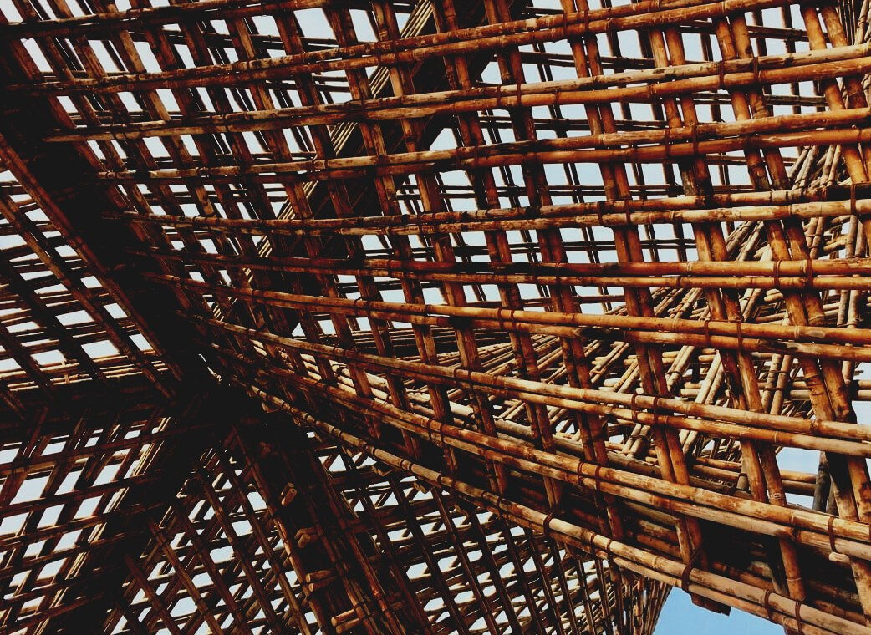

UPWOOD
Up-skilling construction workers in wood construction methods for energy-efficient buildings

UPWOOD
Up-skilling construction workers in wood construction methods for energy-efficient buildings

methods for energy-efficient buildings

UPWOOD
Up-skilling construction workers in wood construction methods for energy-efficient buildings

methods for energy-efficient buildings

UPWOOD
Up-skilling construction workers in wood construction methods for energy-efficient buildings

methods for energy-efficient buildings

UPWOOD
Up-skilling construction workers in wood construction methods for energy-efficient buildings

truction methods for energy-efficient buildings

UPWOOD
Up-skilling construction workers in wood construction methods for energy-efficient buildings

methods for energy-efficient buildings

UPWOOD
Up-skilling construction workers in wood construction methods for energy-efficient buildings

methods for energy-efficient buildings

UPWOOD
Up-skilling construction workers in wood construction methods for energy-efficient buildings

methods for energy-efficient buildings

UPWOOD
Up-skilling construction workers in wood construction methods for energy-efficient buildings

TRAINING & ASSESSMENT
MATERIAL

Learning Unit 4
- Lessons 1&2: Energy-efficiency value of wood as a building material and wooden constructions.

TRAINING & ASSESSMENT
MATERIAL

Learning Unit 4
- Lesson 1: Energy-efficiency value of wood as a building material and wooden constructions.

TRAINING & ASSESSMENT
MATERIAL

Learning Unit 4
- Lesson 1: Energy-efficiency value of wood as a building material and wooden constructions.

TRAINING & ASSESSMENT
MATERIAL

Learning Unit 4
- Lesson 1: Energy-efficiency value of wood as a building material and wooden constructions.

TRAINING & ASSESSMENT
MATERIAL

Learning Unit 4
- Lesson 1: Energy-efficiency value of wood as a building material and wooden constructions.

TRAINING & ASSESSMENT
MATERIAL

Learning Unit 4
- Lesson 1: Energy-efficiency value of wood as a building material and wooden constructions.

TRAINING & ASSESSMENT
MATERIAL

Learning Unit 4
- Lesson 1: Energy-efficiency value of wood as a building material and wooden constructions.

TRAINING & ASSESSMENT
MATERIAL

Learning Unit 4
- Lesson 1: Energy-efficiency value of wood as a building material and wooden constructions.

CONTENT
1. CONTENT 1
2. INTRODUCTORY PARAGRAPH 2
3. TIMBER BUILDINGS AND ITS ENERGY EFFICIENCY BEHAVIOR. 3
3.1. THERMAL TRANSMMITTANCE PRINCIPLES. 3
3.2. THERMAL INSULATION 8
3.3. THERMAL BRIDGES 17
3.4. ENERGY EFFICIENCY CERTIFICATES 23
4. CLIMATE INFLUENCE ON WOODEN BUILDINGS 26
4.1. CLIMATE INFLUENCE ON WOODEN BUILDINGS 26
4.2. INFLUENCE OF WOOD USE IN THE ENVIRONMENT 29

INTRODUCTORY PARAGRAPH
During all the construction processes, one mandatory subject is always the consideration of the energy efficiency of the whole building, especially nowadays, that an environmental concern is reaching every global sector. For this reason, an efficient construction typology is key to reduce the energy consumption required to adequate the hygrothermal conditions.
In this unit, the main principles of thermal transmittance will be analysed, in order to obtain a methodology to analyse different material’s behaviour against diverse thermal conditions, and to apply these principles to the use of timber materials.
One of the concerns of this topic is to show and prove the good properties of wood in terms of thermal transmittance, compared to some of the most used construction systems, such as concrete or ceramic bricks.
Once the principles of thermal transmittance are established, it is important to highlight some other factors which play a very important role in order to improve the energy efficiency of the building, such as, constructive elements disposition, different insulating systems, prevention of thermal bridging. For this reason, some of them will also be addressed and analysed to complete the training of the construction professional workers.
Aside of these developments, concerning the global sustainability topic, it is important to consider the impact of wood exploitation in terms of energy requirements, to ensure that the whole process of timber construction is developed under environmentally friendly processes.

TIMBER BUILDINGS AND ITS ENERGY EFFICIENCY BEHAVIOR.

THERMAL TRANSMMITTANCE PRINCIPLES.
In order to have an adequate acknowledge of the principles of thermal transmittance, it is important to understand the behaviour of materials in terms of heat transfer. These values will be really useful to calculate heat loss of all opaque parts of the building, and to be able to design each enclosure system of the building, considering roofs, horizontal partitions, vertical partitions, façade walls, and even every façade openings, for the sake of avoiding as much heat loss as possible.
Heat energy
One kilocalorie (1 kcal or 1 000 calories) is the amount of heat (energy) needed to raise the temperature of one kg of water by one degree Celsius (°C). The SI standard unit for energy is Joule (J). One kcal is approximately 4.18 kJ (this varies slightly with temperature). Another unit is the Btu (British thermal unit). One Btu roughly corresponds to 1 kJ.
Conversion table for units of work, energy and heat
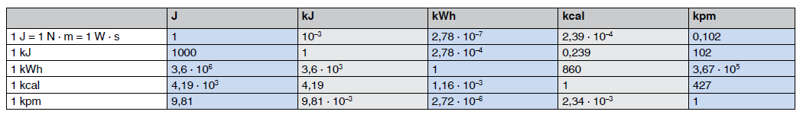
Sorce:https://www.bossard.com/global-en/assembly-technology-expert/technical-information-and-tools/technical-resources/conversion-tables/conversion-table-for-units-of-work-energy-and-heat/
Thermal conductivity (k) or (λ)
In simple terms this is a measure of the capacity of a material to conduct heat through its mass. Different insulating materials and other types of material have specific thermal conductivity values that can be used to measure their insulating effectiveness. It can be defined as the amount of heat/energy (expressed in kcal, Btu or J) that can be conducted in unit time through unit area of unit thickness of material, when there is a unit temperature difference. Thermal conductivity can be expressed in kcal m-1 °C-1, Btu ft-1 °F-1 and in the SI system in watt (W) m-1 °C-1. Thermal conductivity is also known as the k-value or λ-value. Thermal conductivity value is characteristic of each material and component, and it is easy to find into the Technical Specifications of each material provided for each distribution company. It is important to notice that the lower the thermal conductivity value and thicker the material, the better behavior in terms of insulation and energy efficiency.
Coefficient of thermal conductance “λ” (kcal m-2 h-1 °C-1)
This is designated as l (the Greek letter lambda) and defined as the amount of heat (in kcal) conducted in one hour through 1 m2 of material, with a thickness of 1 m, when the temperature drop through the material under conditions of steady heat flow is 1 °C. The thermal conductance is established by tests and is the basic rating for any material. lt can also be expressed in Btu ft-2 h-1 °F-1 (British thermal unit per square foot, hour, and degree Fahrenheit) or in SI units in W m-2 Kelvin (K)-1.
Thermal resistivity
The thermal resistivity is the reciprocal of the k-value (1/k).
Thermal resistance (R-value)
The thermal resistance (R-value) is the reciprocal of l (1/l) and is used for calculating the thermal resistance of any material or composite material. The R-value can be defined in simple terms as the resistance that any specific material offers to the heat flow. A good insulation material will have a high R-value. Each material has its own Thermal Resistance, whose value depends on two factors: Width (e) and Thermal conductivity (λ). This relation is covered in expression (1).
$$R=\frac{e}{λ}$$ | (1)

Coefficient of heat transmission (U) (kcal m-2 h-1 °C-1)
The symbol U designates the overall coefficient of heat transmission for any section of a material or a composite of materials. It is expressed as watts per square metre-kelvin (W/m²·K), and it is inversely proportional to the value of Total Thermal Resistance (R_{T}) of a given wall solution, as formulated in the expression (2).
$$U=\frac{1}{R_{T}}$$ | (2)
It can also be expressed in other unit systems. The U coefficient includes the thermal resistances of both surfaces of walls or flooring, as well as the thermal resistance of individual layers and air spaces that may be contained within the wall or flooring itself.
Permeance to water vapour (pv)
This is defined as the quantity of water vapour that passes through the unit of area of a material of unit thickness, when the difference of water pressure between both faces of the material is the unit. It can be expressed as g cm mmHg-1 m-2 day-1 or in the SI system as g m MN-1 s-1 (grams metre per mega Newton per second).
Resistance to water vapour (rv)
This is the reciprocal of the permeance to water vapour and is defined as rv = 1/pv.

The average thermal conductivity values registered of the most common materials can be seen in board 1.
Material | Thermal Conductivity (λ)  -the lower the better-
- Wood (Nordic Pine) | 0.15 – 0.30 W/(m·K)
- Reinforced Concrete | 2.30 - 2.50 W/(m·K)
- Steel | 50 W/(m·K)
- Ceramic brick | 0.30 – 0.85 W/(m·K)
- Synthetic thermal insulation | 0.025 – 0.050 W/(m·K)
- Natural thermal insulation | 0.035-0.040 W/(m·K)
Board 1. Thermal conductivity of the most common materials.
As can be observed in Board 1, wood is one of the constructive materials with better thermal properties, since its thermal conductivity is more than 7 times lower than Concrete’s conductivity and about 2 times lower than ceramic brick’s conductivity.
Nevertheless, obviously, construction components are not usually made of only one single material, but are composed of a sequence of layers as can be seen in Figure 1, where each one of them fulfils some specific roles. Particularly, insulation materials are disposed in order to improve significatively the thermal behavior of the building.
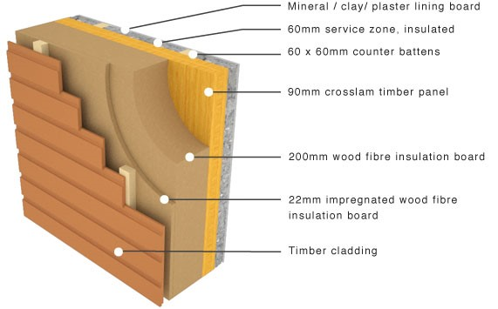
Fig. 1. Wall section, composed of a sequence of layers of different materials.
For this reason, to be able to obtain the thermal transmittance (U) of a whole building closure or partition (e.g. façade wall) the calculation requires the thermal resistance (R) of each layer (considering its thickness “e” and thermal conductivity “λ”), in order to get the total thermal resistance, as expressed in the expression (3), and then the Thermal Transmittance (U) of the whole section.
R_{T} = R_{se} + R₁ + R₂ + ··· + R_{n} + R_{se} | (3)
As can be seen in the expression (3), the total thermal resistance of a section is taken from the sum of each layer’s thermal resistance, plus the values “R_{se}” and “R_{si}” that concern to the outer and inner air thermal resistance. These two values depends on each closure typology, as can be determined in board 2.
Closure position & flow direction |  | R_{se} | R_{si}
Vertical closures, with horizontal flow | 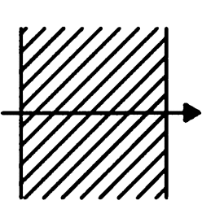 | 0,04 | 0,13
Horizontal closures, with upward flow | 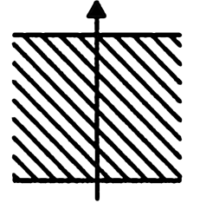 | 0,04 | 0,10
Horitzontal closures, with downward flow | 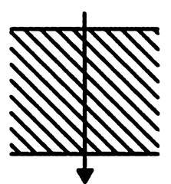 | 0,04 | 0,17
Board 2. Superficial thermal resistance of closures in contact with the outer air.

THERMAL INSULATION
As it has been mentioned in the previous point, the control of thermal transmittance of the chosen materials for the project is crucial in order to ensure the minimum heat loss through the building enclosures.
Thermal insulation is defined as the reduction of heat transfer (the transfer of thermal energy between objects of differing temperature) between objects in thermal contact.
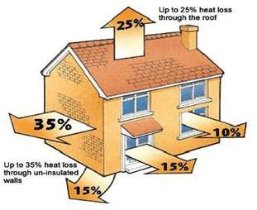
For that reason, aside of using the best constructive system, the choice of an adequate insulation and its adequate disposition is one of the most important topics to reach the lowest heat losses.
Key issues:
• Reducing the amount of energy used from fossil fuels is the most important factor in promoting sustainability.
• Insulation has the greatest potential in order to reduce CO2 emissions.
• Energy conserved through insulation use far outweighs the energy used in its manufacture. Only when a building achieves a ‘LowHeat’ standard does insulation’s embodied carbon become significant.
There are dozens of types of materials with great insulation properties, as can be seen in the following board of accessible materials in the insulation market:
Insulation Materials
Inorganic Materials | Organic Materials
Glass Wool | Petrochemical | Natural
Rock Wool | Expanded Polystyrene (EPS) | Cellulose
Calcium silicate | Extruded Polystyrene (XPS) | Coconut
Foam Glass | Phenol Formaldehyde (PF) | Flax Wool
Perlite | Polyurethane (PUR) | Hemp
Vermiculite | Polyisocyanurate (PIR) | Recycled Cotton
Expanded Clay Aggregate | Urea-formaldehyde (UF | Sheep Wool
Vacuum Insulation Panels (VIPs) (new materials) | Expanded polylactic acid (PLA) (new materials) | Wood Wool
Thermosheets (new material) |  | Expanded Cork
Aerogel (new material) |  | Greensulate (Fungus) (new material)
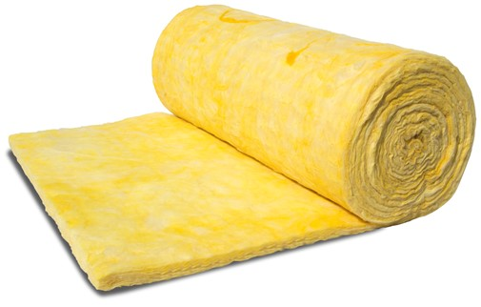
Nevertheless, the most commonly used are glasswool (fiberglass) and mineral wool:
- Fiber glass.
This is the most common type of insulation material used in residential, commercial or industrial applications. It is also referred to as Glasswool insulation and is made from up to 80% recycled glass material. The glass is melted in a furnace then sent through a spinner to create fibres. The glass fibres in glasswool insulation creates millions of tiny air pockets which trap air. The R-value of glasswool insulation ranges from an R1.5 for walls up to an R6.0 for ceiling applications. Glasswool insulation is relatively inexpensive in comparison to other insulation products. Nevertheless, despite its installation is quite easy, it is a hazardous material to handle, since some particles that it drops can be harmful for the eyes, the lungs or even the skin.
Glasswool features and benefits:
- High thermal performance – year round comfort
- Non-combustible
- Saves energy – lower energy bills
- Soft to handle and install
- Lightweight, flexible and resilient

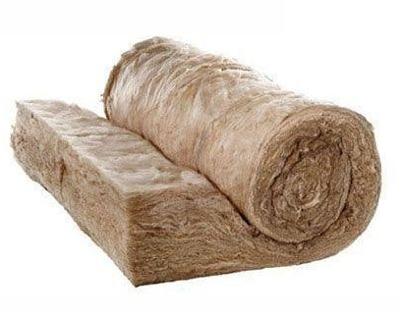
Between the different types of glasswool, one of the most relevant types is the Earthwool insulation, from the Knauf house. Earthwool insulation is manufactured using ECOSE technology which is a sustainable, renewable bio-based binder that contains no added formaldehyde. No traditional petrol-based chemicals are used. Earthwool is one of the most common thermal insulation materials used in residential, commercial and industrial applications. It is available in wall, ceiling, floor and acoustic product types.
Earthwool features and benefits:
- Low irritant product which means it is virtually itch free.
- Environmentally-friendly natural binder.
- High thermal performance – year round comfort
- Acoustic products available
- Non-combustible
- 50 year warranty
- Compression packed – more product per pack
- Odourless

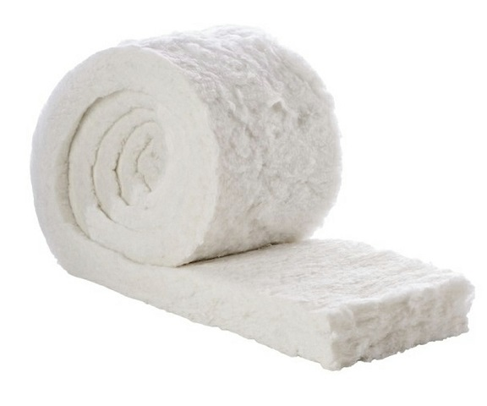
- Polyester insulation.
Polyester is manufactured from a minimum of 50% recycled PET plastics such as drink bottles which would otherwise end up in land fill. Polyester fibres are bonded together by heat and no binder chemicals are used. This gives polyester its rigid, yet flexible structure. Polyester is a popular thermal insulation material as it contains no breathable particles and is a popular choice for asthma or severe dust allergy home occupants. Polyester material is soft to touch and itch-free, making it a great DIY material for your renovation or retrofit project, as no protective clothing is required while handling it. In comparison to glasswool, polyester thermal insulation material can be more expensive. However, it can be used for the same applications as glasswool material. This includes; commercial and residential buildings. The material is pre-cut to fit timber-frames studs in walls, ceilings, underfloor and mid-floor joist spacings. Examples of polyester insulation products include; Bradford Polymax, Autex Greenstuf Polyester, and Autex acoustic range (Quietspace, Etch, Workstation).
Polyester features and benefits:
- Made from recycled materials
- The product itself can be recycled
- Non-allergenic particles, breathe easier
- Non-toxic and non-irritant, safe to touch
- Non-flammable
- 50 year durability warranty

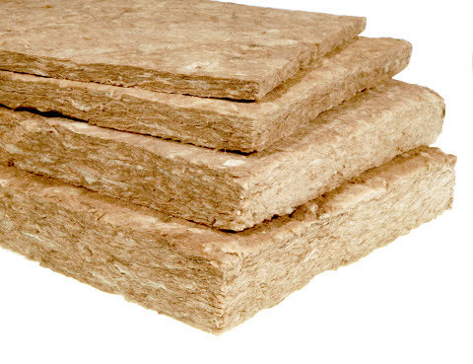
- Mineral wool.
Rockwool insulation is made from rock such as basalt. Rockwool is manufactured by first melting the rock and then spinning it at high temperatures to create fibres which make up insulation batts or rolls. No binder resin is used during this process. Rockwool insulation has exceptional fire ratings as it is non-combustible, does not conduct heat and can withstand temperatures of above 1000°C. Rockwool’s ability to insulate works by trapping air in between the fibres, which restricts heat transfer. Generally, Rockwool is three times more expensive than glasswool insulation. Rockwool offers high R-values, acoustic and fire ratings. Rockwool can be used in both residential and commercial settings, although Rockwool is most commonly used in wall constructions between adjacent tenancies. Its disposition and properties are quite similar to the fiber glass, but its not that hazardous to handle.
Rockwool features and benefits:
- Highly durable
- Performance not adversely affected by water contact
- Fire Resistance
- Non-combustible
- High acoustic ratings
- High thermal performance
- 10 year warranty

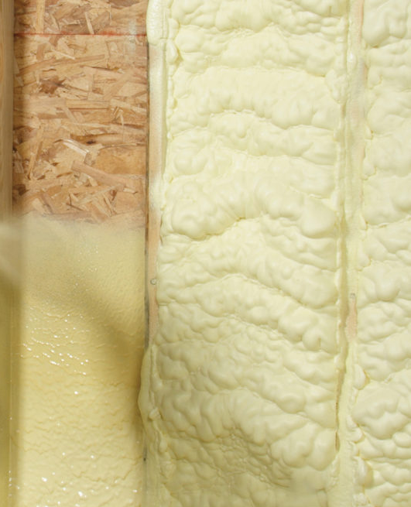
- Spray Foam Insulation
Spray foam is usually more expensive than most other insulation materials. It requires a blowing machine to install and usually requires a trained professional installer to use it. This means that the overall cost may be higher. Spray foam is better at sealing air leaks, preventing water leaks and minimizing mould growth. This means that the insulation is less likely to be damaged, so check-ups aren’t required as often. Foam spray has a lifespan of around 50 years, if it is kept dry. Similar to rigid boards, there are two main categories of spray foams called open-cell foams and closed-cell foams. Open cell spray foams are denser and spongier due to the air that gets inside the cells, giving it greater sound dampening effects. Open cell foam is less expensive than closed cell insulation. However, closed cell is more rigid and solid in structure making it better at keeping air and water from leaking into your home. Foam spray is an effective thermal insulation material in residential homes and is suitable for retrofit applications.

Spray foam insulation features and benefits:
- Reduce energy bills.
- Airtight seal, reducing air draughts in your home.
- Deters mould growth.
- Long lifespan up to 50 years approx.
- Eco-friendly product.
Nevertheless, aside of providing an adequate heat seal, the industrial processes to manufacture each material are also relevant in order to evaluate their efficiency. Some of the most eco-friendly materials with as good insulating properties as the previously mentioned, are cellulose, sheep natural wool, wood fiber or even natural cork:
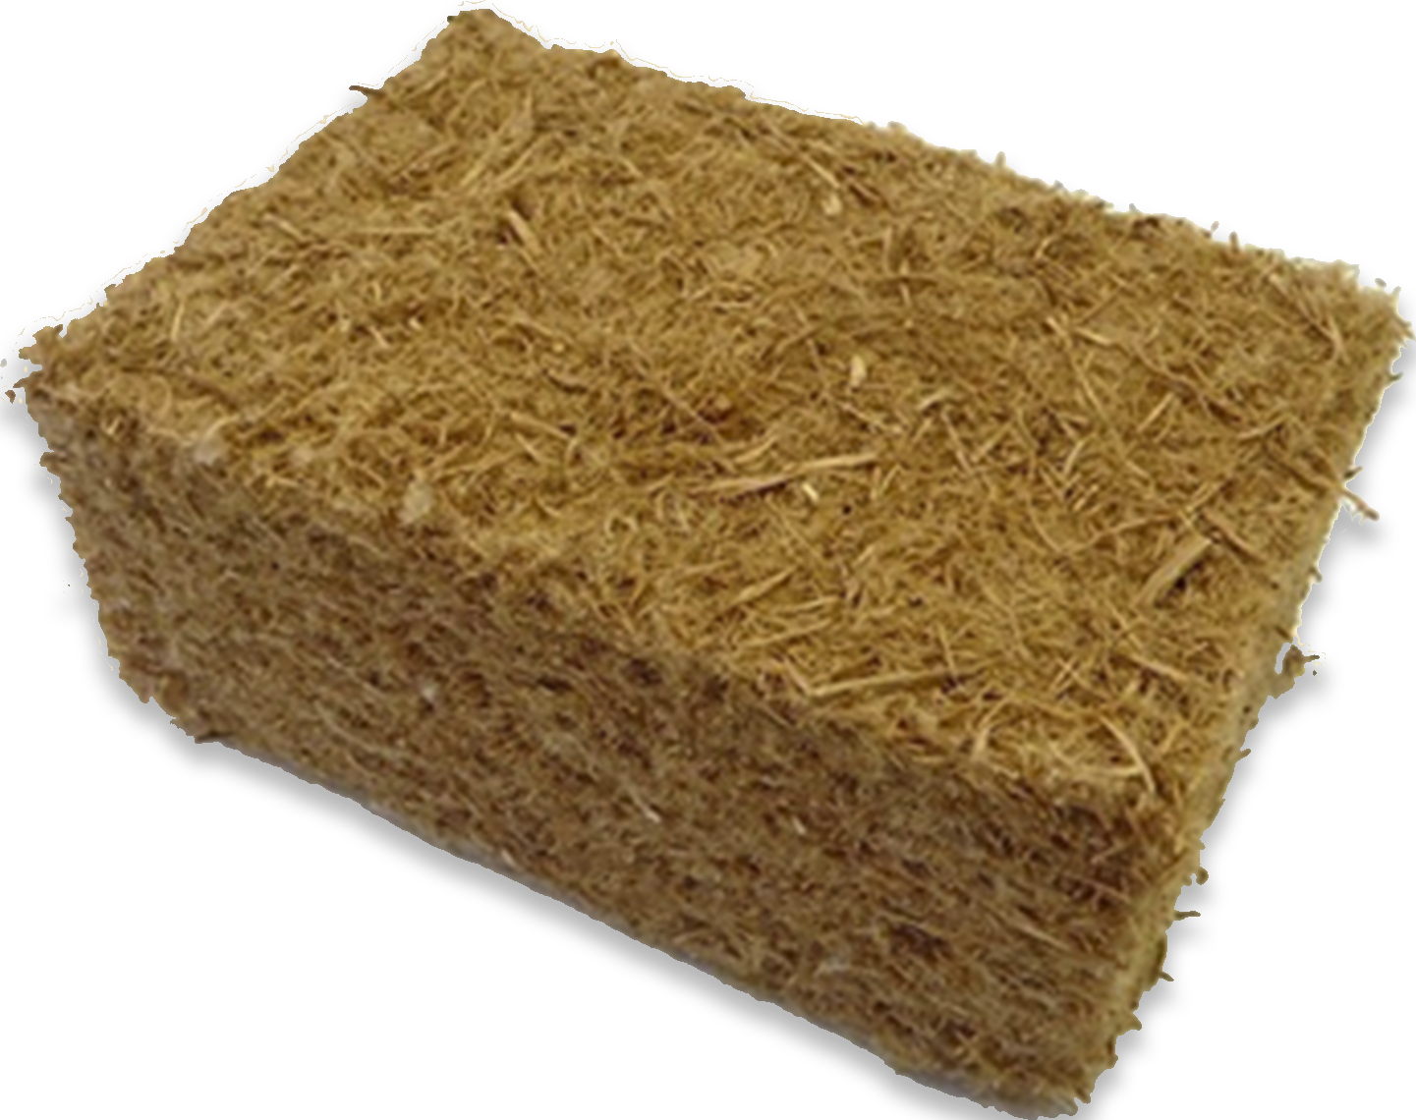
- Wood Fibre insulation
The raw material for wood fibre insulating materials originates from sustainable forestry, which complies with the strict requirements of the FSC (Forest Stewardship Council). The goal of the FSC® is the promotion of environmentally-friendly, socially responsible and economically sustainable forest management. Consequently, those using wood fibre insulation materials make a significant contribution to climate protection. An average tree stores approximately 1 tonne of CO² during its growth and at the same time produces 0.7 tonnes of oxygen. The CO² stored in the trees in the form of carbon remains in the finished product – while the replanted trees continue to absorb the greenhouse gas CO² from the atmosphere.
Wood fibre insulating materials is characterised by good compression resistance as well as dimensional stability. Cut sizes maintain their form and are safe to install even when done so overhead. Thanks to the flexible structure of the insulation material, smaller unevenness can easily be levelled.
Wood fibre insulation features and benefits:
- Completely organic material.
- Nice thermal insulation properties.
- Good properties as acoustic insulation.
- Presents good hygroscopic properties, regulating the humidity levels into the dwelling.
- Diverse formats for different constructive solutions.

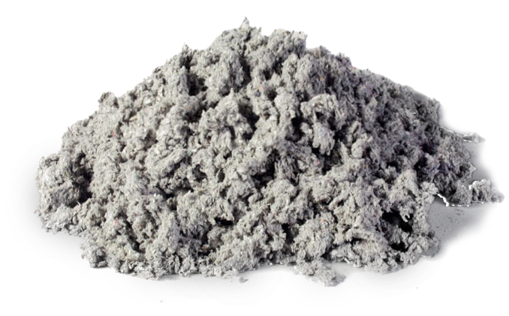
- Cellulose /Paper fibres.
This insulation material is obtained from recycled paper, which is obtained from the daily production excesses. After some cutting processes, the paper is mixed with boron salts, which provides great properties against fire, insects, and fungus. Another ecologic feature of this material is that this industrial process does not require much energy, since the process is quite simple.
Even if some people might think that this material is not safe against fire, the truth is that thanks to the treatments that the cellulose receives, it can stand temperatures up to 1500ºC, which provides a high fire protection.
Another feature of this material is its hygroscopic properties, which means that this material has great properties to manage the humidity of interior spaces.
The most suitable areas of application for this material are the following ones:
- Air injected insulation for timber frame applications in roofs, walls and ceiling.
- Open blown insulation in attic floors.
- Prefabricated wall and roof cassettes.
- Ideal insulation for renovation of roofs and floors.
Cellulose insulation features and benefits:
- Ecological insulation made from recycled paper, also available boron free
- Joint free, no cutting, insulates all sizes of cassettes
- High quality cellulose thanks to modern production facilities
- Excellent insulation in winter
- Excellent summer heat protection
- Water vapor open for a healthy internal climate
- Long term slump resistance with minimum material
- Suitable for use with machines of all sizes
- Trained installer network ensures high quality installation

THERMAL BRIDGES
Thermal bridges are sensible parts of the building where there is a variation in the uniformity of the construction. This variation can be caused by a different thickness of the enclosure or the characteristics of the materials used, the penetration of constructive elements with varying conductive properties or the difference between external and internal area, (like walls , floors or roofs).
In the sensible points its easier the formation of mold thanks to superficial condensations created due to the temperature drop of the interior surfaces preferably in winter.
There are different locations where thermal bridges are more susceptible to occur.
Integrated in the enclosure:
- Pillars integrated in the enclosure of the facade;
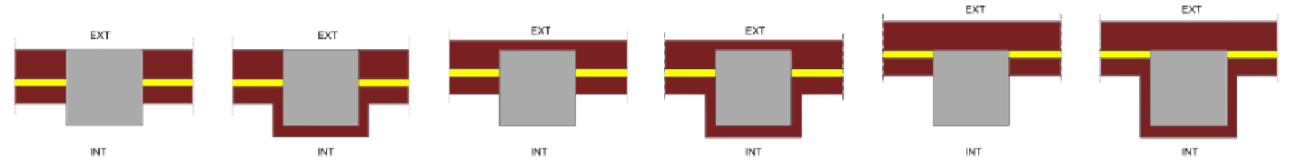
- Perimeter of holes and skylights;
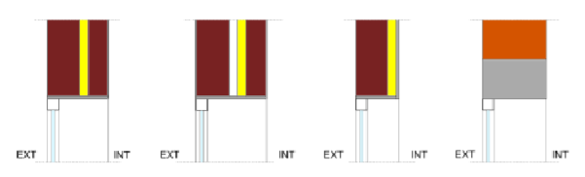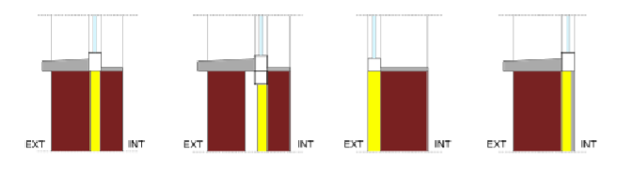
- Blind boxes;
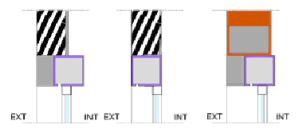
- Other integrated thermal bridges.

Between encounter of enclosures:
- Front slab in façades;
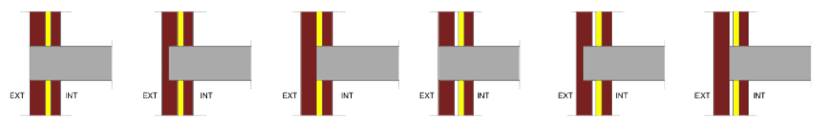
- Joints between facades and roofs;
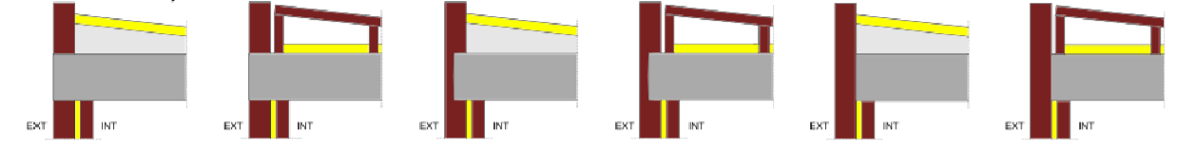
- Roofs with parapet;
- Roofs without parapet;
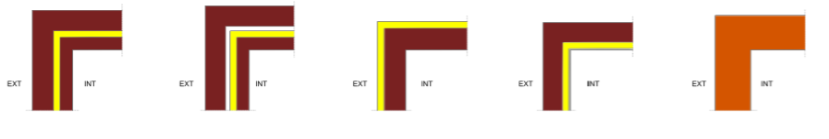
- Joints between facades and enclosures in contact with soil;
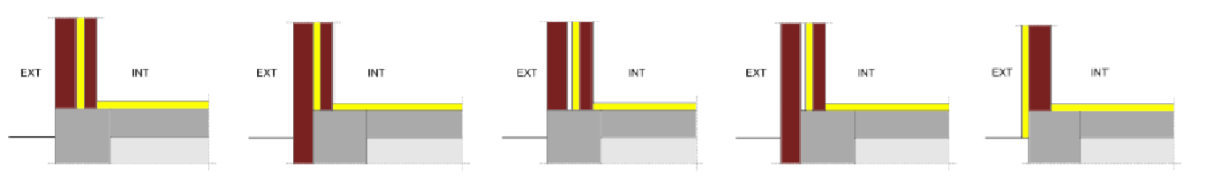
- Joints of the façade with slab;
- Joint of the façade with underground walls.
Corners or encounters between facades that can be inward or prominent considering the exterior surroundings.
Encounters of cantilevers with facades.
Encounters of internal partition with external enclosures.

Transmission of heat and condensation in thermal bridges
The effects of the flow of heat produced by thermal bridges in the enclosure of the building represent the onset of bidimensional or tridimensional flow of heat instead of uniform behavior as unidimensional flow.
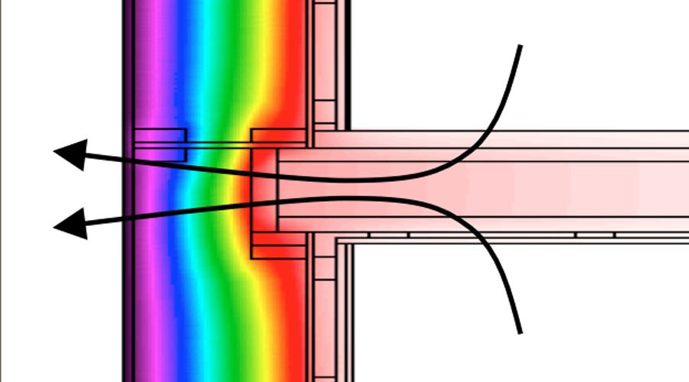
Precise calculation of global thermal behaviour of thermal enclosure can be done using numerical methods that allow to obtain more reliable results, but with more effort regarding modelling. Instead, simplified formulations are less effort consuming and are based in different fundaments.

Calculus of thermal bridges
There are different methods to calculate thermal bridges, the election of one or another method depends on the information available, level of modeling desired and final use of calculus.
DETAILED METHODS
This method can be tridimensional or bidimensional.
In the first method we evaluate the global effect of thermal bridges through tridimensional models of numerical calculus. This approach needs an elevated cost for modelling and provide little information prior simulation.
The bidimensional model analyze the thermal bridge’s effect using the formula of thermal transmission and implies the application of the formula of superposition of flows.
SIMPLIFIED METHODS
It is possible to carry out simplified additional formulas to help the calculus of bidimensional components during heath transmission. The more usual are estimating ψj, estimating the length, and with corrector factor U.
The main formula used in order to calculate this transmission is the following:
Φ_{T} = (∑U_{i}A_{i} +∑ψ_{j}L_{j})(θ_{i} – θ_{e}) =U_{m}A_{T} (θ_{i} – θ_{e})
Where:
Φ_{T:} Heat flow for conductivity[W];
U_{i}: Thermal transmittance of the element and the enclosure [W/m²K], of
Area A_{i} [m²];
ψ_{j}: Thermal transmittance of the j joint of the building [W/m²K] and L_{j} is the length of that joint [m];
X_{k}: Thermal transmittance of the specific thermal bridge k [W/K];
U_{m}: Average thermal transmittance of the enclosure [W/m²K], including the thermal bridges’ effect.
A_{T}: Total transmission surface [m²]

Superficial resistance
Collecting Thermal Transmittance(U) of constructive elements implies considering thermal properties of composing materials, coating coefficient or superficial resistance that shape convection and radiation produced in the exterior and interior surface of elements. The value of superficial resistance is influenced by the aim of the calculus, varying between thermal temperature flow, considering the position and disposition of the element too.
By doing so, different values are used for the evaluation of the request, the calculus of condensation risk or the use of a particular element such glass.

External condensation
Another effect of the Thermal bridges is the increase towards the formation of superficial condensation in the exterior face of the constructive element existing cold points in the area affected by the thermal bridge; the result is a major flow in that section.
To be able to analyze condensations in cold points, psychometric diagrams are needed. These types of diagrams link dry temperature, relative humidity, and absolute humidity.
Absolute humidity is a magnitude that shows the quantity of water vapor contained by air, it is measured in grams per every kilogram of air.
The quantity of water that can be contained by air in vapor form has a limit that depends on temperature and its value increase when the temperature is higher.
The proportion between the quantity of water in vapor form contained by air and the saturated quantity, expressed in percentage, it is known as relative humidity (HR).
When we have a relative humidity of 100% the air has reached the limit value for saturation humidity.
When absolute humidity is given, 100% relative humidity is reached at dew temperature, when air temperature is below dew temperature there is an excess of humidity that produces condensation in liquid form.
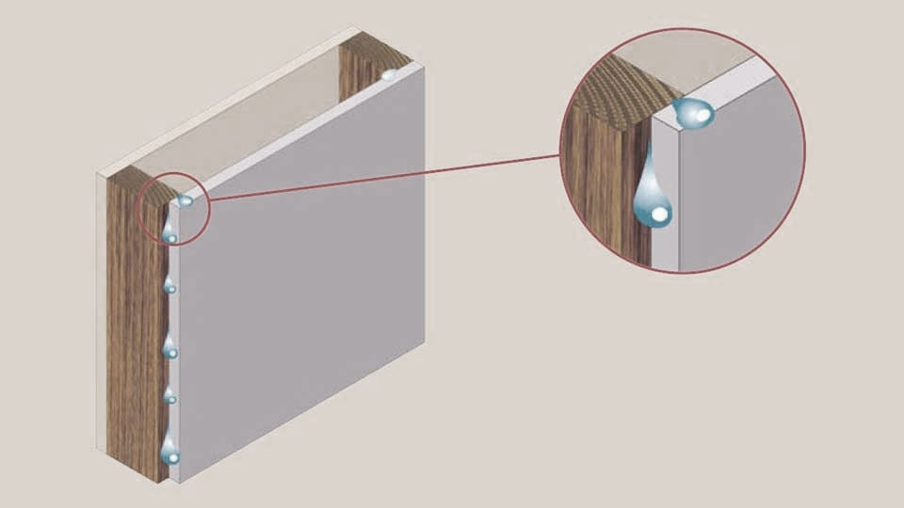
The cold surfaces in thermal bridges are conducive to appearance of this type of condensations.

Limitation of risk of mold formation
The superficial condensations represent a health risk increasing the chances of mold formation, especially when relative humidity is above 80% on a surface during various days.
This condition can be simplified if the temperature of the interior surface is above the superficial acceptable temperature, this implies a relative humidity above 80% in the interior surface of the enclosure.
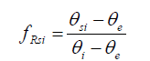
Using the method of Temperature factors allows to compare two adimensional factors: Temperature factor of interior surface (fRsi) and Util temperature factor of interior surface (fRsi,min). The first one must be bigger than the second, for every month of the year.
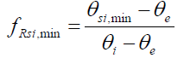
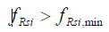
Minimum temperature on the interior surface of the enclosure(C)
Interior temperature (C)
Exterior temperature ( C)
Acceptable superficial temperature (C)

ENERGY EFFICIENCY CERTIFICATES
According to the European Legislation, an Energy Efficiency Certificate is the one recognized in one of the States members of the European Union or a proper juridic figure in charge, that indicates the energy efficiency of a building.
To determinate the results of the Energy Efficiency of the building considered, first, the methodology of the calculus has to be determined.
Different aspects should be taken in account regarding building’s energy consumption, technical and administrative conditions should be established for the release of the certification, and a common framework should be set in all the national territory in the form of an energy efficiency label.
The use of a label allowed the user of the building to know all the characteristics regarding energetics and performances, giving the opportunity to evaluate and compare with others.
Knowing the Energy Efficiency of a buildings means to have the value of the energy consumption needed by the building to satisfy the energetic demand in normal conditions of occupancy and use.
This procedure is applied in new buildings and rehabilitations of old buildings, excluding the ones that remains open or that are protected in some way. Industrial and Agricole buildings are excluded too.
To obtain the Energy Efficiency Qualification of a building there are two possible options: the general one or the simplified option.
The general one is based in the evaluation of the energetic demand of the buildings through the comparison of this one to another building of reference. The simplified option checks directly the energetic demand of the buildings through the limitations of the characteristic parameters of the enclosure and interior partitions that compose its thermal enclosure.
An informatic programme is used to obtain all the calculations, the ones that can be used should be accredited by official channels and recognized in the entire national territory.
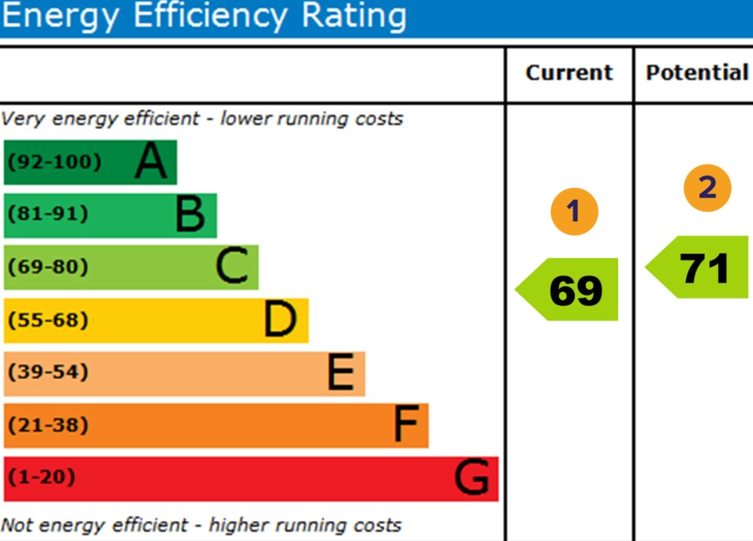
The certificate will have a duration of 10 years maximum and the owner of the building is responsible of updating the certificate.
Fig. 2. Energy efficiency certificate requirements.
Source 2. Green network energy

Usually the labels are standardized, the calcification of energy efficiency assigned to the building will correspond to the index of classifications of energy efficiency obtained, the scale is made by seven letters from A ( more efficient) to G (less efficient).

PASSIVHAUS CERTIFICATE
The PASSIVHAUS Certificate is another kind of official certification that focuses on the sustainability of the building.
A building with this type of certification reach a level of 75% reduction in necessity of heating and cooling meaning a low level of energy cost for the owner. To reach this characteristics, the building has to have a good shape able to reduce the contact surface to the exterior and decrease climatization necessities, have the proper orientation of the windows to take advantage of the sun and ventilate properly.
The requirements to this kind of certification are a proper level hating requirements, of cooling requirements, of primary energy (hot water,electricity…), tightness.

CLIMATE INFLUENCE ON WOODEN BUILDINGS

CLIMATE INFLUENCE ON WOODEN BUILDINGS
Wood is a material slightly vulnerable to the climate adversities, and there are 4 agents that can become a threat to the wood integrity. These agents are solar radiations, water contact, fungus, and insects.
    - Solar radiation.
The sun light that gets to earth surface is composed of a wide radiations spectrum that can be divided in three groups, as can be seen in the figure below: Ultraviolet rays, visible rays, and Infra-red rays.
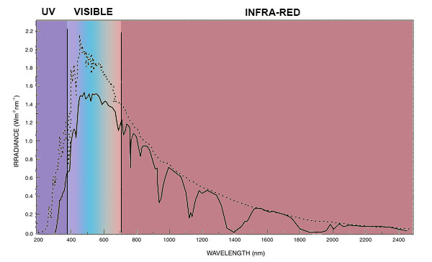
Fig. 3. Solar radiation spectrum
Source 2. UPV
- Ultraviolet rays (UV). This first group of radiations represent the 5% of solar light. This radiation has a big amount of energy, which can get to penetrate deeply the wood surface, even if there is a varnish layer over its surface. For this reason, this group of radiations can be considered as the most harmful for wood and its mechanical properties.
- Visible rays. This group of radiations constitutes the part of the rays that can be visible. This has not enough energy to cause major damage to the wood. In any case it could cause some colour variations in wood.
- Infra-red rays. This spectrum of radiations which are not visible contribute to the wood degradation caused for the Ultraviolet-rays, due to the increase of temperature. Also the increase of temperature that these radiations provide can be problematic for the joint of varnish and the wood.

    - Water
Water is a component that can easily travel through the varnish layer, and interfere in the relative humidity of the wood. This increase of relative humidity can foster the spread of fungus that damage the wood integrity.
    - Fungus
As mentioned in the previous topic, a high rate of humidity, together with some features, such as temperature and amount of Oxigen, can forward the appearance of fungus in wood elements.
    - Insects
The insects that can affect wood elements can be divided in four different groups:
- Anobides. This is the case of the commonly found woodworms, that use to attack cured woods, both sapwood and heartwood parts. When a piece of wood is attacked by this insect typology, it doesn’t lose all its properties. The trace that this type of insect leaves is a set of 1.5 / 3 mm diameter holes in the wood surface.
- Lictides. This type of insect that only affects to some species of hardwood with a big content of starch. Its attack is really aggressive to the wood structure, and can induce to a loose of its main structural properties. The trace that this type of insects leave is a set of holes similar to the previously mentioned, and the drop of a really soft dust, really similar to flour.
- Cerambycids. This is a very aggressive type of insect. It is quite hard to appreciate the attack until an advance step of the process, when most of the damage has already taken place. When a piece of wood is infested with this insect, it will probably lose most of its physical properties. The trace of this specimen is a few holes of 7-8 mm diameter.

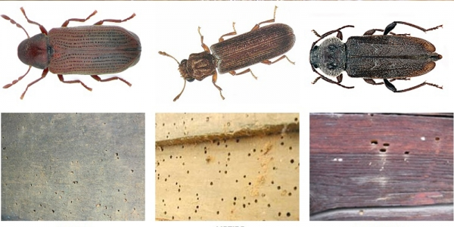
Fig. 4. aspect and trace of Anobides, Lictides and Cerambicides.
Source 3. Termitastratamientos.es
- Termites. This is the most aggressive type of xylophage, that does not leave a trace at all, and does not show any sign on the exterior, since it lives in darkness. As a result, this specie attacks only the inner part of the wood sections, reducing drastically the section of the wood element, and its properties.
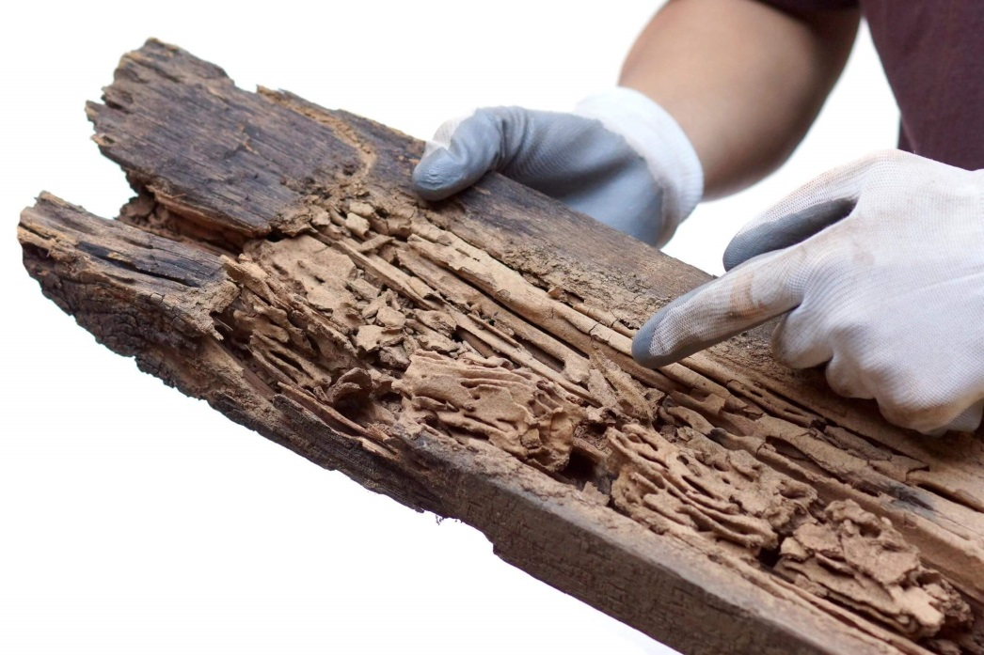
Fig. 5. Trace of termites in a wood plank
Source 4. Lloyd Pest Control
The main trick in order to control the decomposition of wood is to have an adequate control of humidity. Once fungus start to decompose the wood, if the humidity values are above 22% that fungus can spread on, so in order to protect wood against fungus spread, it is recommended to keep the humidity content below 19%.

INFLUENCE OF WOOD USE IN THE ENVIRONMENT
One of the most interesting features of wood in the construction sector is that the environmental footprint that it carries is virtually null, and even negative, as can be seen in figure below.
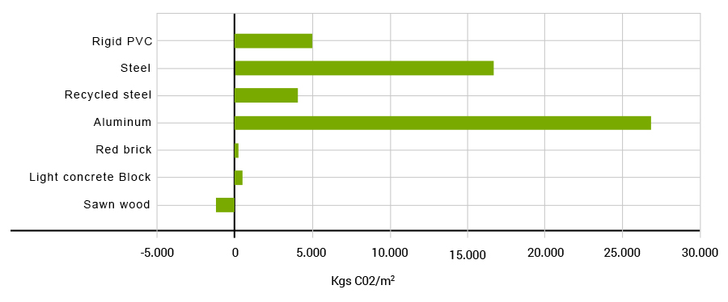
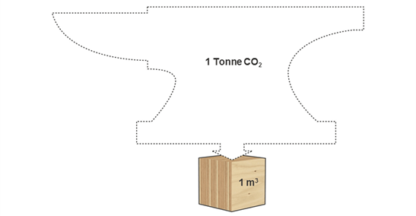
This means that the use of wood in the construction sector is not only less detrimental for the environment than other materials, but can be even positive, since its use assures the reforestation of vast surfaces with new trees. The main reason why this is positive is because new trees absorb more CO2 from the atmosphere than older trees, and since the use of wood require some deforestation and a compensating reforestation, this means that older trees with less absorption will be replaced by newer trees with better absorption values. Also, the wood used in construction can still absorb some CO2, enhancing the renovation of the air surrounding the buildings, and contributing to the global CO2 absorption. At the end, in most cases, this material can get to absorb about one tone of CO2 per m³ of wood.
Source 5. Metsä Wood
Fig. 6. CO2 absorption per m3 of wood.
This absorption works together with the CO2 emissions that can get registered during the construction process, ending with an average of CO2 emissions/absortions that favours the CO2, as can be seen in the figure 7.
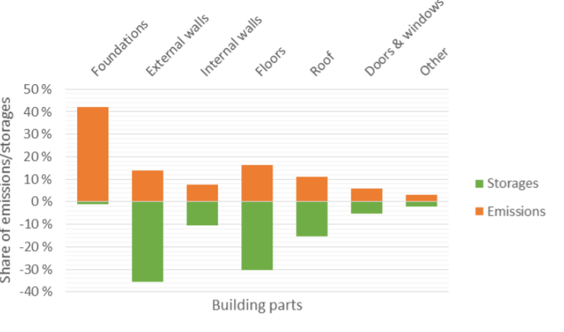
Fig. 7. Share of emissions/storages of wood.
Source 6. Carbon storage in wood-based buildings. Matti Kuittinen.
In contrast with other construction materials, wood does not require highly demanding industrial processes, since the wood obtained directly from the forests have good physical and mechanical properties. In some cases, some specialised sawing processes are required, but those do not require much energy. For this reason, as can be seen in figure 8, the ratio between CO2 emissions and storages, shows a much better performance than other construction materials, such as concrete, bricks or steel.
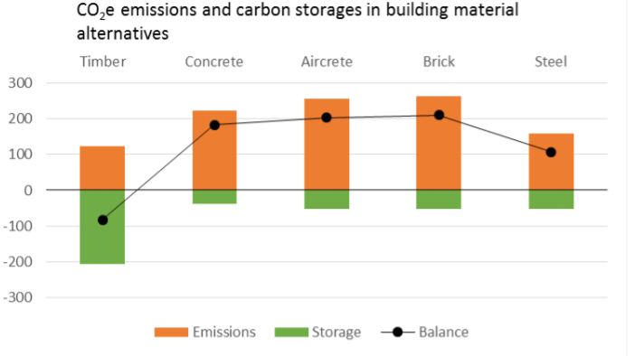
Source 7. Carbon storage in wood-based buildings. Matti Kuittinen.
Fig. 8. CO2 emissions and carbon storages in building material alternatives

