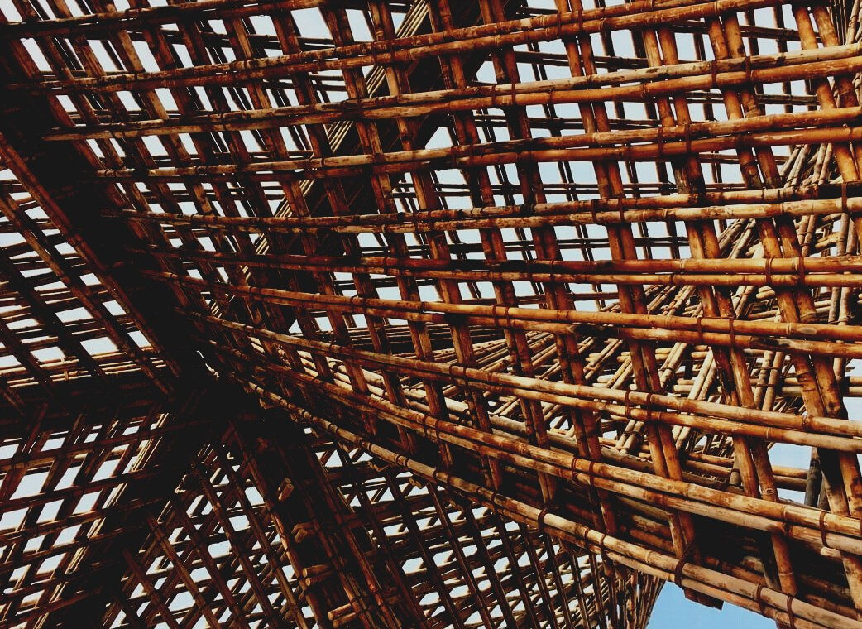
UPWOOD
Up-skilling construction workers in wood construction methods for energy-efficient buildings

UPWOOD
Up-skilling construction workers in wood construction methods for energy-efficient buildings
construction workers in wood construction methods for energy-efficient buildings

methods for energy-efficient buildings

UPWOOD
Up-skilling construction workers in wood construction methods for energy-efficient buildings

methods for energy-efficient buildings

UPWOOD
Up-skilling construction workers in wood construction methods for energy-efficient buildings

truction methods for energy-efficient buildings

UPWOOD
Up-skilling construction workers in wood construction methods for energy-efficient buildings

methods for energy-efficient buildings

UPWOOD
Up-skilling construction workers in wood construction methods for energy-efficient buildings

methods for energy-efficient buildings

UPWOOD
Up-skilling construction workers in wood construction methods for energy-efficient buildings

methods for energy-efficient buildings

UPWOOD
Up-skilling construction workers in wood construction methods for energy-efficient buildings

TRAINING & ASSESSMENT
MATERIAL
Learning Unit 3
Lesson 6: Fire safety and protection solutions
CONTENT
1 INTRODUCTORY PARAGRAPH 2
2 FIRE SAFETY OF TIMBER BUILDINGS 4
2.1 GENERAL DESIGN APPROACHES 4
2.1.1 Prescriptive design 4
2.1.2 Performance based design 5
2.2 Fire engineering basics 6
2.2.1 Fire protection objectives 6
2.2.2 Fire performance 6
2.3 Fire performance characteristics 9
2.3.1 Reaction to fire 9
2.3.2 Resistance to fire 12
3 LIST OF REFERENCES 15

INTRODUCTORY PARAGRAPH
Safety in case of fire is set to be one of the most important “Basic requirements for construction works” for every building. It doesn’t matter whether it is made of steel, reinforced concrete, timber or masonry. All buildings shall be designed and built in such a way that in the event of an outbreak of fire, they remain load-bearing capacity for specified time, generation and spread of combustion products is limited, fire spread is limited, occupants of the building can leave the building or be rescued by other means and safety of rescue teams is considered.
Currently, there are no harmonised mandatory Europe wide regulations for fire safety of buildings and this is because each of the Member states have their own understanding and traditions in fire protection of buildings, fire safety management and firefighting process and infrastructure. At the same time every and each of Member states have their own set of mandatory fire safety regulations and codes. In this unit general principles of most common fire protection design approaches will be demonstrated.
Despite the fact that fire regulations and codes differ between member states there have been established some common ground for main design principles through Eurocodes and common performance characteristics of construction works and building products through common classification and testing standards that are related to harmonization of European market of construction products. Main performance characteristics, which are horizontal for every construction material, will be addressed and analysed to give basic knowledge about performance characteristics and design principles of timber construction products to the construction professional workers.

FIRE SAFETY OF TIMBER BUILDINGS

GENERAL DESIGN APPROACHES
In fire engineering there are two main approaches how to do assessment and verification of construction works to judge and verify their suitability for designated intended end use. One of approaches is so called “Prescriptive design” method which is most common and widely spread worldwide. Other method is “Performance based” design approach which is based on fire risk assessment.

Figure 1. General fire design approaches

Prescriptive design
Widely spread design principle all over the world. Building fire protection design is made following well established and well-known building fire safety solutions. Prescriptive building codes is easy to use because they usually are straightforward, they can be read as an instruction of what needs to be done to achieve predefined fire protection requirements. However, the downside of this approach is that it is impossible to have well-known solution for every situation or there might be many exceptions which differ between different occupation type buildings. Need for use of analytical design methods and many exceptions can make prescriptive design approach very difficult for engineers without experience in field of fire engineering.

Performance based design
Because of modern design tools and development of analysis methods becoming more and more popular design approach, which is based on fire risk assessment and assumed fire behaviour in buildings. Design method do not rely on predefined fire safety levels but define its own fire safety level from case to case to each individual building design depending on predefined fire protection objectives. The main fire protections objectives usually are life safety or property safety with their subobjectives.
For example, in residential buildings, hotels and public buildings main fire protection objective will be human lives. At the same time in archive buildings, storehouses, museums and historical buildings, protection of property could be important as well. Performance based design usually is used to verify new prescriptive rules and to analyse buildings outside the scope of prescribed building codes. In Europe there are some countries where performance-based design is not permitted and countries where it is not allowed to use prescriptive rules in case of large area or high-rise multi-storey buildings. Since use of timber in construction works are going to increase among midrise and high-rise buildings it is expected that need for performance-based fire engineering design solutions will increase too.

Fire engineering basics

Fire protection objectives
Every building design shall have its fire safety objectives, if they are not defined explicitly by fire code then they shall be made and documented by engineer responsible for fire protection design. Most common fire protection objectives (can be defined as goals) for buildings are:
- Minimization of fire-related injuries and prevention of loss of life
- Minimization of fire-related damage to building and its contents
- Minimization of fire caused interruptions of operations and business
- Limiting fire caused impact on environment.

Fire performance
To initiate ignition there is need for three basic fire components demonstrated in Figure 2.

Figure 2. Fire components
Every fire protection measure limit fire by taking out one or more of fire components.
In case fire is initiated, the amount of available fuel, its properties (ignitibility and combustion energy) and amount of oxygen will define the severity of fire.
Fire events are illustrated with heat release or temperature rise curves. Simplified real fire curves of some fire types are demonstrated in Figure 3.
Temperature/ Heat release rate
Time
Fire ignition and development phase
Full developed fire
Cooling phase
Temperature curve for uncontrolled fires
Fire curve for controlled fires
Smouldering fires
Figure 3. Natural fire temperature or heat release rise curves.
Actual fires visible in Figure 3 are much more complicated. It is nearly impossible to predict actual fire event because it depends on many different factors, such as, building configuration (geometry and size), construction composition, heat response of structures, amount of available oxygen and ventilation conditions, available fuel and occupancy type.
To make approximate calculations for design verification purposes simplified fire temperature rise curves have been developed during large scale testing. The calculation methods of nominal temperature time curves and simplified natural fire curves for local fires and compartment fires are proposed in Eurocode 1 part 1-2 (EN 1991-1-2). Design fire curves in Eurocode 1 are used for fire resistance assessment of construction works, they do not describe ignition phase and time before flashover. Nominal fire curves (Figure 4) are intended for simplified but more conservative calculations. They do not take into account fire cooling phase and therefore constructions usually are overdesigned.

Figure 4. Nominal temperature time curves
Parametric fire curves describe cooling phase and therefore depend on fuel characteristics expressed as fuel load density on square meter of floor area. Fuel load comprises of active fuel load and passive fuel load. Active or movable fuel load is combustible materials placed in the room. Items such as chairs, bed, cupboards, clothes and electronic devices does not have reaction to fire classes as construction products do but there have been done researches about average fuel load densities in buildings with different occupancies (see Table 1).
Table 1. Fuel load density values according EN 1991-1-2 and Latvian national building code
Occupancy type | Average, [MJ/m²]  1991-1-2 | 80% fractilr, [MJ/m²]  EN 1991-1-2 | Fire load,  LBN 201-15  (Latvian national values)
Dwellings | 780 | 948 | < 300
Hospital (room) | 230 | 280 | Not defined
Hotel (room) | 310 | 377 | < 300
Library | 1500 | 1824 | 600 – 1200
Office | 420 | 511 | 300 – 600
School (classroom) | 285 | 347 | 300 – 600
Shopping centre | 600 | 730 | 600 – 1200
Theatre (also cinema) | 300 | 365 | 300 – 600
Transport (public place) | 100 | 122 | 300 – 600
In some Member states, like in former Member state United Kingdom it is not required to determine exact fuel load because it is already foreseen by defining occupancy type of the building or room.
Passive fire load is derived by calculating total amount of combustible construction products. Weather material is combustible or not can be found from reaction to fire classification according EN 13501-1. For example, all materials below reaction to fire class A2 can be assumed to be combustible and class A2 and A1 materials are non-combustible.

Fire performance characteristics

Reaction to fire
In Europe for the purpose of indication of material ignitibility, characteristic heat energy release, lateral flame spread, smoke production and emission of flaming droplets, reaction to fire classification has been established. Classification is applicable to construction products only, that means that reaction to fire class describe properties of products not material. This is reasonable way how to characterise constructions products because different products made of the same material can have different reaction to fire classes.
Construction products can be classified with appropriate reaction to fire class using one of the following methods:
Method 1 – Product shall be tested and then classified according EN 13501-1;
Method 2 – Product complies reaction to fire class A1 according EC decision 96/603/EC without the need for testing. This method is typical for mineral materials and metals with no or small amount of organic additives or coatings;
Method 3 – Product are considered to satisfy the requirements for reaction to fire class in accordance with relevant EC decision without the need for further testing. This method is applicable for well known construction products which have other reaction to fire classes than A1 and are well tested, such products are structural timber materials, wood-based boards and wooden claddings and floorings. Lists of these products and relevant reaction to fire classes are publicly available.
Reaction to fire class demonstrates tendency of fire growth upon application of small source of fire (30 kW - Trash bin fire). The classification has been derived from set of tests where main tests is room corner test. Corner test is European version of large-scale room test which is used in Australia, New Zealand and United states.
Most of solid wood products can be classified as D-s2, d0 class products, provided the density of material is greater than 390 kg*m⁻³ and thickness of material is greater than 18 mm. Classification without need for further testing is applicable for thermally or chemically unmodified solid wood products, such modification shall be tested.
Simplified explanation of reaction to fire classification demonstrated in Figure 5 as explained in EN 13501-1 show that products classified with reaction to fire class E can release large amount of energy when set of fire and energy rise reaches the flashover point within 2 minutes. Many organic and biobased insulation and cladding materials belong to this group. For example, natural unmodified timber belongs to class D which means that it will contribute to fire but point of flashover is reached considerably later.
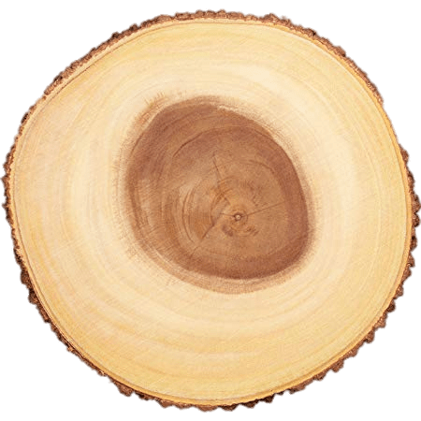
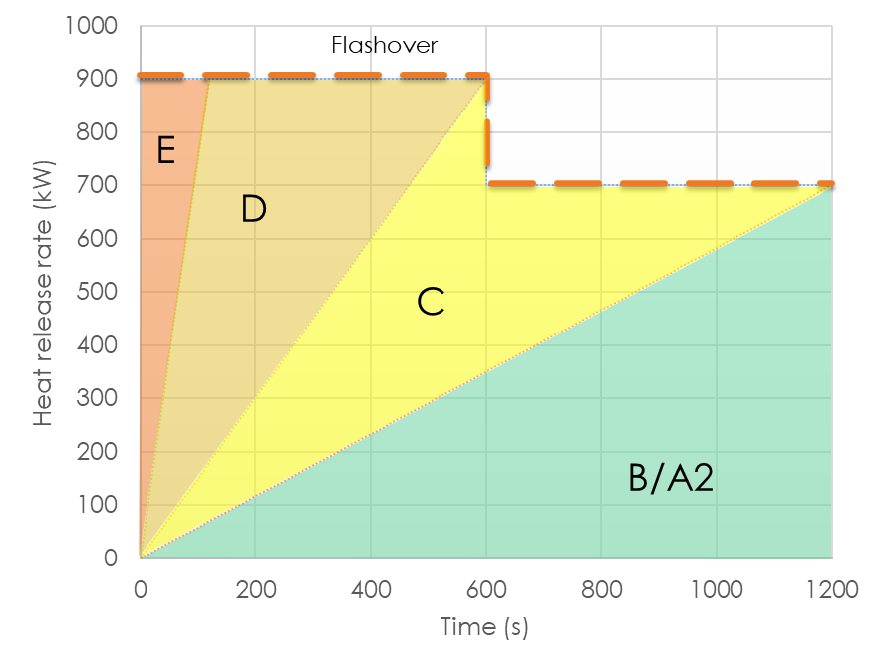
Figure 5. Reaction to fire classification relationship with fire growth rates obtained in ISO 9705 (large scale room tests) tests
With special fire-retardant treatments, it is possible to achieve better reaction to fire classes for timber materials, however such treatment leads to unpredictable fire resistance of wooden material because it may change charring rate of timber or might change mechanical properties.
Fire-retardants doesn’t make timber inflammable and after prolonged exposure to fire it will burn as ordinary untreated timber or worse. Fire-retardant treatments do not last and they have to be renewed on regular basis. On top of all that any of chemical treatments makes timber relatively dangerous to surrounding environment because they slowly release chemical substances in to the soil and air. Most of chemicals used as fire retardants are aggressive to metals, product combability shall be checked during the design process.

Resistance to fire
Second important characteristic of construction products, timber structures inclusive, is their resistance to fire. This parameter shows how long the product will do what they are intended for in the building after serious fire outbreak. For example, how long compartment wall or door will hold fire contained inside the compartment limiting the speed of fire spread within building without collapse of particular compartment walls or ceilings. Resistance to fire also demonstrates how long separating structures limits temperature rise and smoke leakages.
Resistance to fire can be verified by calculation or testing. In case of calculation EN 1995-1-2 applies for timber structures.
When resistance to fire is calculated, the result is expressed as time of resistance in minutes. Classification shall be done according provisions of EC decision 2000/367/EC (as amended). There are three most common resistance to fire aspects:
- Load bearing capacity in case of fire. Indicated with “R” symbol in fire resistance class. Represents fire resistance of load bearing structures
- Integrity of separating structures. Indicated with “E” symbol in fire resistance class
- Thermal insulation properties of separating structure. Indicated with “I” symbol in fire resistance class.
Product fire resistance class is demonstrated as appropriate combination of applicable symbols on product label or approval documentation.
R E I 30
Load bearing capacity | Integrity | Insulation property | Expected performance duration
Figure 6. Resistance to fire classification example
Classification example in Figure 6 is not the only one. There is additional resistance to fire classes demonstrating specific aspects of different construction products. For example, structural columns will have only “R” class because they don’t have separating function, but fire doors will have additional symbols which represents smoke spread limitation performance, durability of safety devices etc.
Calculations are cost efficient way how to determine approximate fire resistance properties of structures. However, there are very limited knowledge about appropriate calculation methods and only the very basic constructions and situations are covered by Eurocodes. When doing fire resistance calculations for structures designer have to choose one of three design scenarios:
- Prescriptive fire scenario with nominal or standard fire growth as shown in Figure 4 is considered.
- Performance based scenario with fire decay phase taken in to account so called parametric fire scenario. To use this scenario compartment fuel load, geometric parameters and surface boundary conditions shall be known.
- Advanced fire modelling where changes of material properties under elevated temperatures are considered.
Structural elements can be assessed using prescriptive fire model or parametric fire model but entire structural systems can be assessed using advanced fire models.
Main difference between prescriptive and parametric fire models is fire growth scenarios which demands different approaches when determining charring rates of timber materials. When prescriptive model is used timber charting rates are obtained from tabulated values in Eurocode 5 part 2. In most cases it is 7mm/min. For parametric models charring rate needs to be calculated by taking in to consideration the fire load.
Reliable but costly way to determine fire resistance properties is testing and classification of construction solutions according relevant testing standards and classification standard EN 13501-2.
However, with above mentioned fire characteristics it is not enough and there are additional classifications for roof coverings and covering systems which describe fire spread over the roof surfaces – Fire performance of roof coverings from external fire exposure (Classification standard EN 15301-5).
Unified European standards which addresses fire spread over the facades is under development and expected soon. National requirements for limitation of fire spread over façade systems in some of European countries already exist and they shall be followed when relevant.

LIST OF REFERENCES
- Babrauskas V., Ignition Handbook: Principles and applications to fire safety engineering, fire investigation, risk management and forensic science. - Issaquah, WA : Fire Science Publishers, 2003. - 1116 p.
- Purkiss J.A., Fire Safety Engineering : Design of Structures, 2nd Edition. - New Delhi, India: Elsevier, 2007. – 389 p.
- Fontana M., Kohler J., Fischer K., De Sanctis G.. Fire Load Density / SFPE Handbook of Fire Protection Engineering 5th Edition – New York : Springer, 2016 – p. 1131-1142.
- Boverket Handbok, Brandbelastning, 2008. Available: https://www.boverket.se/globalassets/publikationer/dokument/2008/brandbelastning_3.pdf
- Noteikumi par Latvijas būvnormatīvu LBN 201-15 "Būvju ugunsdrošība" MK 2015.gada 30. jūnija noteikumi Nr.333. - https://likumi.lv/ta/id/275006-noteikumi-par-latvijas-buvnormativu-lbn-201-15-buvju-ugunsdrosiba
- INSTA TS 950, Fire Safety Engineering - Comparative method to verify fire safety design in buildings. February 24, 2015
- EAD 130005-00-0304 “Solid wood slab element for use as structural element in buildings”; 2015-07
- EN 1991-1-2:2002 Eurocode 1: Actions on structures - Part 1-2: General actions - Actions on structures exposed to fire
- EN 1995-1-2: Eurocode 5: Design of timber structures - Part 1-2: General - Structural fire design
- EN 13501-1:2018 Fire classification of construction products and building elements - Part 1: Classification using data from reaction to fire tests
- EN 13501-2:2016 Fire classification of construction products and building elements - Part 2: Classification using data from fire resistance tests, excluding ventilation services
- SP Technical Research Institute of Sweden – SP Report 2010:19. Fire safety in timber buildings. Technical guideline for Europe. ISBN 978-91-86319-60-1 – 211 p.

Basic requirements for construction works – definition set by Regulation called as Construction Product regulation (CPR) (EU) No 305/2011 of the European Parliament and of the Council of 9 March 2011 ANNEX I laying down harmonised conditions for the marketing of construction products.

